**MINISTRY OF EDUCATION AND TRAINING**

**FPT UNIVERSITY**

Capstone Project Document

**Job Searching System**

|  |  |
| --- | --- |
| **Group JSS** | |
| **Group members** | Huỳnh Đức Tài – Leader – SE60630  Nguyễn Ngọc Thiện – Member – SE90129  Phạm Quốc Thái – Member – SE60599  Võ Hoàn Thiện – Member – SE60788  Trịnh Văn Hoàng – Member – 01769  Trần Chung Thành – Member – 01611 |
| **Supervisor** | Mr. Trần Đình Trí |
| **Ext. Supervisor** | N/A |
| **Project code** | JSS |

-Hanoi, 08/2015-

# Table of Contents

Table of Contents 2

Definition, Acronyms and Abbreviations 7

4. System Design Description (SDD) 7

4.1. Design Overview 7

4.2. System Architectural Design 8

4.2.1. Choice of System Architecture 8

4.2.2. Discussion of Alternative Designs 8

4.2.3. Description of System Interface 8

4.3. Component Diagram 10

4.4. Detailed Description of Components 11

4.4.1. Controllers 11

4.4.1.1.Class Diagram 11

4.4.1.2.Class Diagram Explanation 12

4.4.1.3.Algorithms of important methods, specified by Flow-Chart 12

4.4.1.3.1. JobController/Detail (Get) 12

4.4.1.3.2. Account/Register (Post) 13

4.4.1.3.3. Profile/Update (Post) 14

4.4.2. DAL – Data Access Layer 15

4.4.2.1.Class Diagram 15

4.4.2.2. Class Diagram Explanation 16

4.4.2.3. Algorithms of important methods, specified by Flow-Chart 16

4.4.2.3.1. JobUnitOfWork/FindJob 16

4.4.2.3.2. JobUnitOfWork/Matching 17

4.4.2.3.3. ProfileUnitOfWork/UpdateCommonInfo 18

4.5. Sequence Diagram 19

4.5.1. Create Job 19

4.5.2. Find Job 20

4.5.3. Apply Job 21

4.5.4. Create Message 22

4.6. User Interface Design 23

4.6.1. HomeController 23

4.6.1.1. Index 23

4.6.1.1.1. Screen 23

4.6.1.1.2. Description 23

4.6.2. AccountController 24

4.6.2.1. Login 24

4.6.2.1.1. Screen 24

4.6.2.1.2. Description 24

4.6.3. ApplicantController 25

4.6.3.1. List 25

4.6.3.1.1. Screen 25

4.6.3.1.2. Description 25

4.6.4. JobController 26

4.6.4.1. Find 26

4.6.4.1.1. Screen 26

4.6.4.1.2. Description 26

4.6.4.2. Create 27

4.6.4.2.1. Screen 27

4.6.4.2.2. Description 27

4.6.4.3. Detail 28

4.6.4.3.1. Screen 28

4.6.4.3.2. Description 28

4.6.4.4. OwnList 29

4.6.4.4.1. Screen 29

4.6.4.4.2. Description 29

4.6.4.5. AppliedJobList 31

4.6.4.5.1. Screen 31

4.6.4.5.2. Description 31

4.6.5. JobPackageController 32

4.6.5.1. Choose 32

4.6.5.1.1. Screen 32

4.6.5.1.2. Description 32

4.6.5.2. Invoice 33

4.6.5.2.1. Screen 33

4.6.5.2.2. Description 33

4.6.6. MessageController 34

4.6.6.1. Inbox 34

4.6.6.1.1. Screen 34

4.6.6.1.2. Description 34

4.6.6.2. Detail 35

4.6.6.2.1. Screen 35

4.6.6.2.2. Description 35

4.6.7. ProfileController 36

4.6.7.1. List 36

4.6.7.1.1. Screen 36

4.6.7.1.2. Description 36

4.6.7.2. Create 38

4.6.7.2.1. Screen 38

4.6.7.2.2. Description 38

4.6.8. TopicController 39

4.6.8.1. List 39

4.6.8.1.1. Screen 39

4.6.8.1.2. Description 39

4.6.8.2. Create 40

4.6.8.2.1. Screen 40

4.6.8.2.2. Description 40

4.6.8.3. Detail 41

4.6.8.3.1. Screen 41

4.6.8.3.2. Description 41

4.7. Database Design 42

4.7.1. Database Diagram 42

4.7.2. Database Description 43

4.7.2.1. Table Administrator 43

4.7.2.2. Table Advertise 43

4.7.2.3. Table AppliedJob 43

4.7.2.4. Table AspNetRoles 43

4.7.2.5. Table AspNetUserClaims 43

4.7.2.6. Table AspNetUserLogins 44

4.7.2.7. Table AspNetUserRoles 44

4.7.2.8. Table AspNetUsers 44

4.7.2.9. Table Benefit 44

4.7.2.10. Table Category 45

4.7.2.11. Table City 45

4.7.2.12. Table CompanyInfo 45

4.7.2.13. Table CompanyInfoCity 45

4.7.2.14. Table Contact 45

4.7.2.15. Table DesiredBenefit 46

4.7.2.16. Table EducationHistory 46

4.7.2.17. Table EmploymentHistory 46

4.7.2.18. Table ExpectedCategory 47

4.7.2.19. Table ExpectedCity 47

4.7.2.20. Table Job 47

4.7.2.21. Table JobBenefit 48

4.7.2.22. Table JobCategory 48

4.7.2.23. Table JobCity 48

4.7.2.24. Table JobLanguage 48

4.7.2.25. Table JobLevel 49

4.7.2.26. Table JobPackage 49

4.7.2.27. Table Jobseeker 49

4.7.2.28. Table JobSkill 49

4.7.2.29. Table Language 50

4.7.2.30. Table Level 50

4.7.2.31. Table Manager 50

4.7.2.32. Table Message 50

4.7.2.33. Table MessageReceiver 50

4.7.2.34. Table OwnSkill 51

4.7.2.35. Table Profile 51

4.7.2.36. Table PurchaseAdvertise 52

4.7.2.37. Table PurchaseJobPackage 52

4.7.2.38. Table Recruiter 52

4.7.2.39. Table ReferencePerson 52

4.7.2.40. Table Report 53

4.7.2.41. Table SchoolLevel 53

4.7.2.42. Table Skill 53

4.7.2.43. Table Staff 53

4.7.2.44. Table Topic 54

4.7.2.45. Table ViewProfile 54

# Definition, Acronyms and Abbreviations

|  |  |
| --- | --- |
| **Name** | **Definition** |
| JSS | Job Searching System |
| App | Application |
| OS | Operating System |
| Admin | Administrator |
| Mod | Moderator |
| API | Application Programming Interface |
| HTTP | Hyper Text Transfer Protocol |

# 4. System Design Description (SDD)

## 4.1. Design Overview

This document describes the technical and user interface design of JSS system. It includes the architectural design, the detailed design of common functions and business functions. It also includes the design of database model, and overall design of user interface.

The architectural design describes the overall architecture of the system and the architecture of each main component and subsystem. It will describe the patterns being used, the role of each component and the role of the system in the working environment.

The detailed design describes static and dynamic structure for each component and functions. It includes class diagrams, class explanations and sequence diagrams of the main use cases.

The database design describes the relationships between entities and details of each entity. It uses notations of SQL Server as it is the database server for developing the system.

The user interface design describes the layout of the system, and some design for the screens.

## 4.2. System Architectural Design

### 4.2.1. Choice of System Architecture

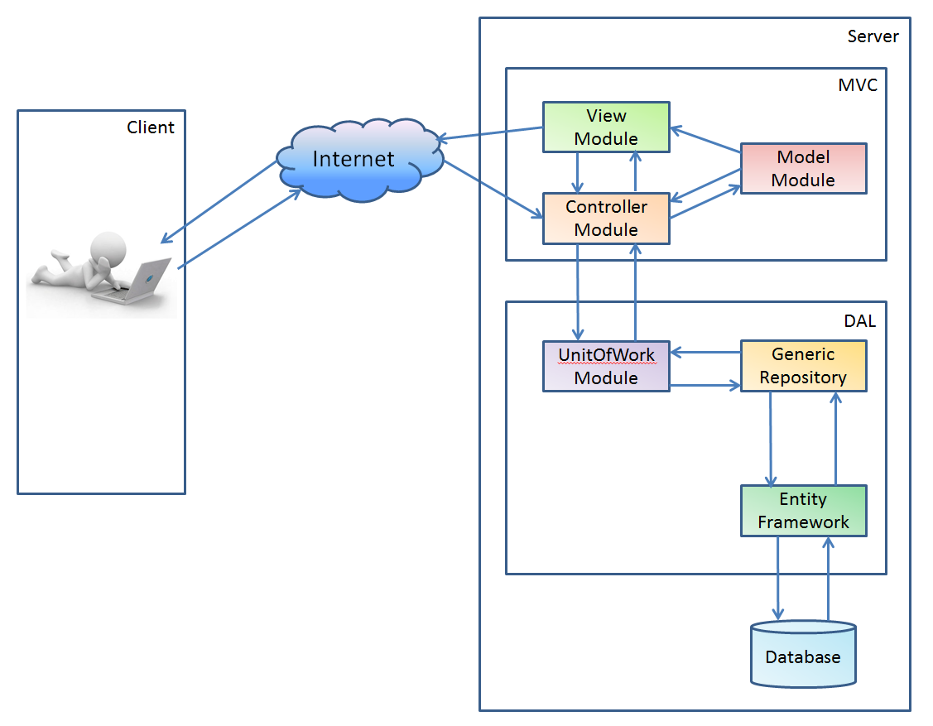

Figure 4. 1 – Architecture diagram

The system realize heavily on Client-Server as the main architecture and MVC pattern to deliver services to its users. Data will be transfer through the internet using some common protocols.

### 4.2.2. Discussion of Alternative Designs

### 4.2.3. Description of System Interface

The main entities of the above diagram will be described as following:

* **Clients:** These include internet browsers running on personal computers, or mobile applications. The web browsers will interact with the web application via normal protocols (HTTP).
* **Server:** The server of the system running on web server. It includes main components Web application. Web application is responsible for creating web pages. This will be developed in ASP.NET Web platform using ASP.NET MVC 5 framework.
* **Entity Framework and Generic Repository:** The data access will accept data of each single table before request to the Database and response to the System.
* **UnitOfWork:** All of multi-table access request will be implemented by using some of Repository.
* **Database:** This is the central data storage for the system. It may be running on a separate server to the Server, or in the same machine. JSS database will use SQL Server 2012 in order to utilize the features provided by Microsoft.NET framework.

The Model-View-Controller (MVC) pattern separates the modeling of the domain, the presentation, and the actions based on user input into three separate classes:

**Model:** The model stores data that it retrieved to the controller and displayed in the view. Whenever there is a change to the data it is updated by the controller.

**View:** The view requests information from the controller. The controller fetches it from the model and passes it to the view that the view uses to generate an output representation to the user.

**Controller:** The controller accept all behavior of user on the view and handle it. The controller can send commands to get data from DAL and convert that data to the model for the view’s presentation.

## 4.3. Component Diagram

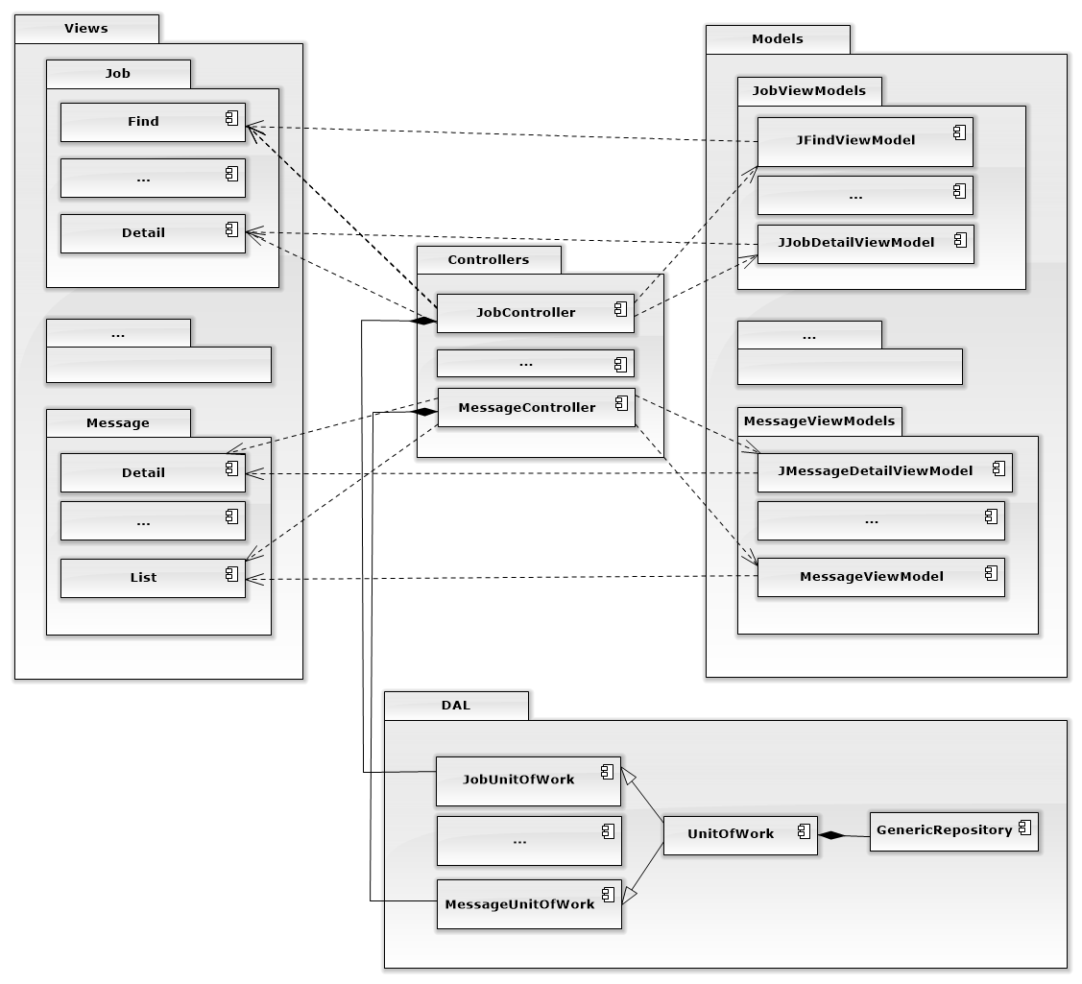

Figure 4. 2 – Component Diagram

## 4.4. Detailed Description of Components

### 4.4.1. Controllers

#### 4.4.1.1.Class Diagram

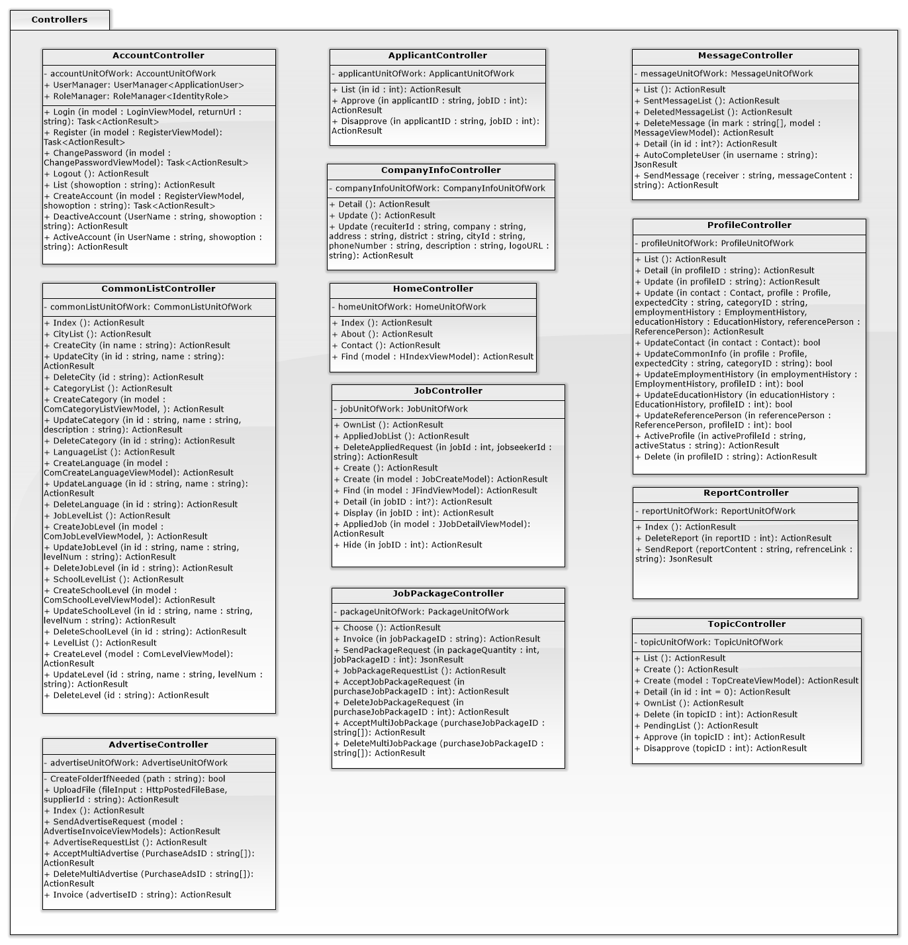

Figure 4. 3 – Controller Class Diagram

#### 4.4.1.2.Class Diagram Explanation

Each Controller is named with format “Entity’s name” as the prefix and “Controller”.

Each Controller do the group of methods for particular entity.

#### 4.4.1.3.Algorithms of important methods, specified by Flow-Chart

##### 4.4.1.3.1. JobController/Detail (Get)

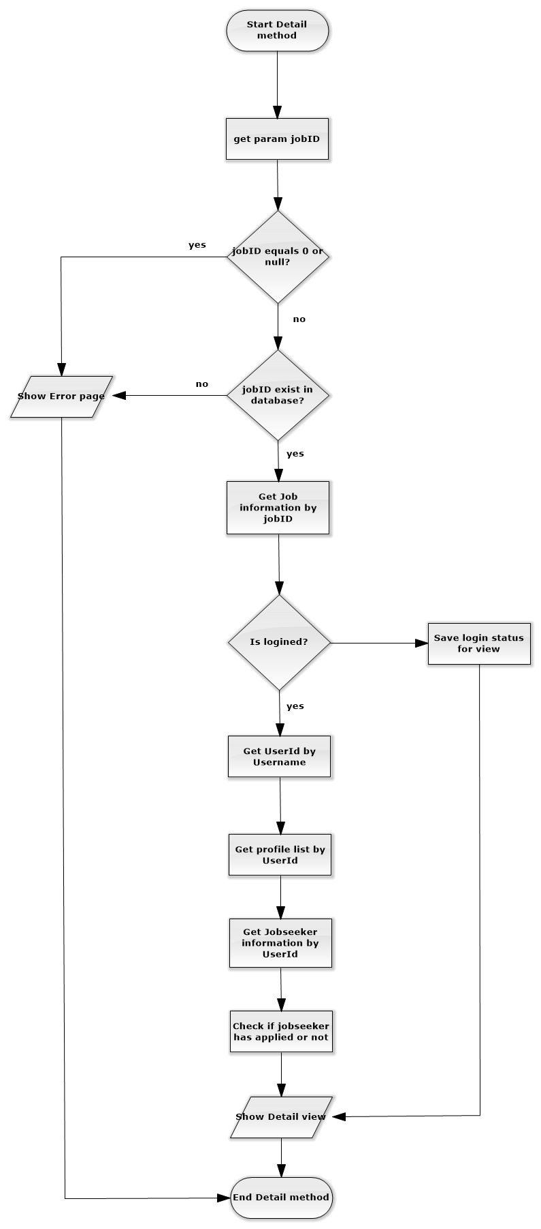

##### 4.4.1.3.2. Account/Register (Post)

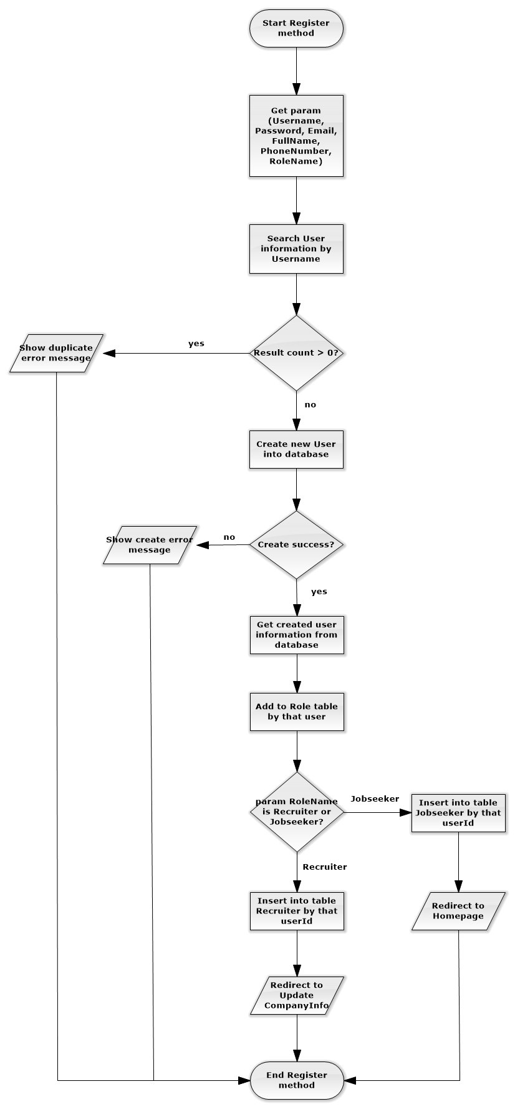

##### 4.4.1.3.3. Profile/Update (Post)

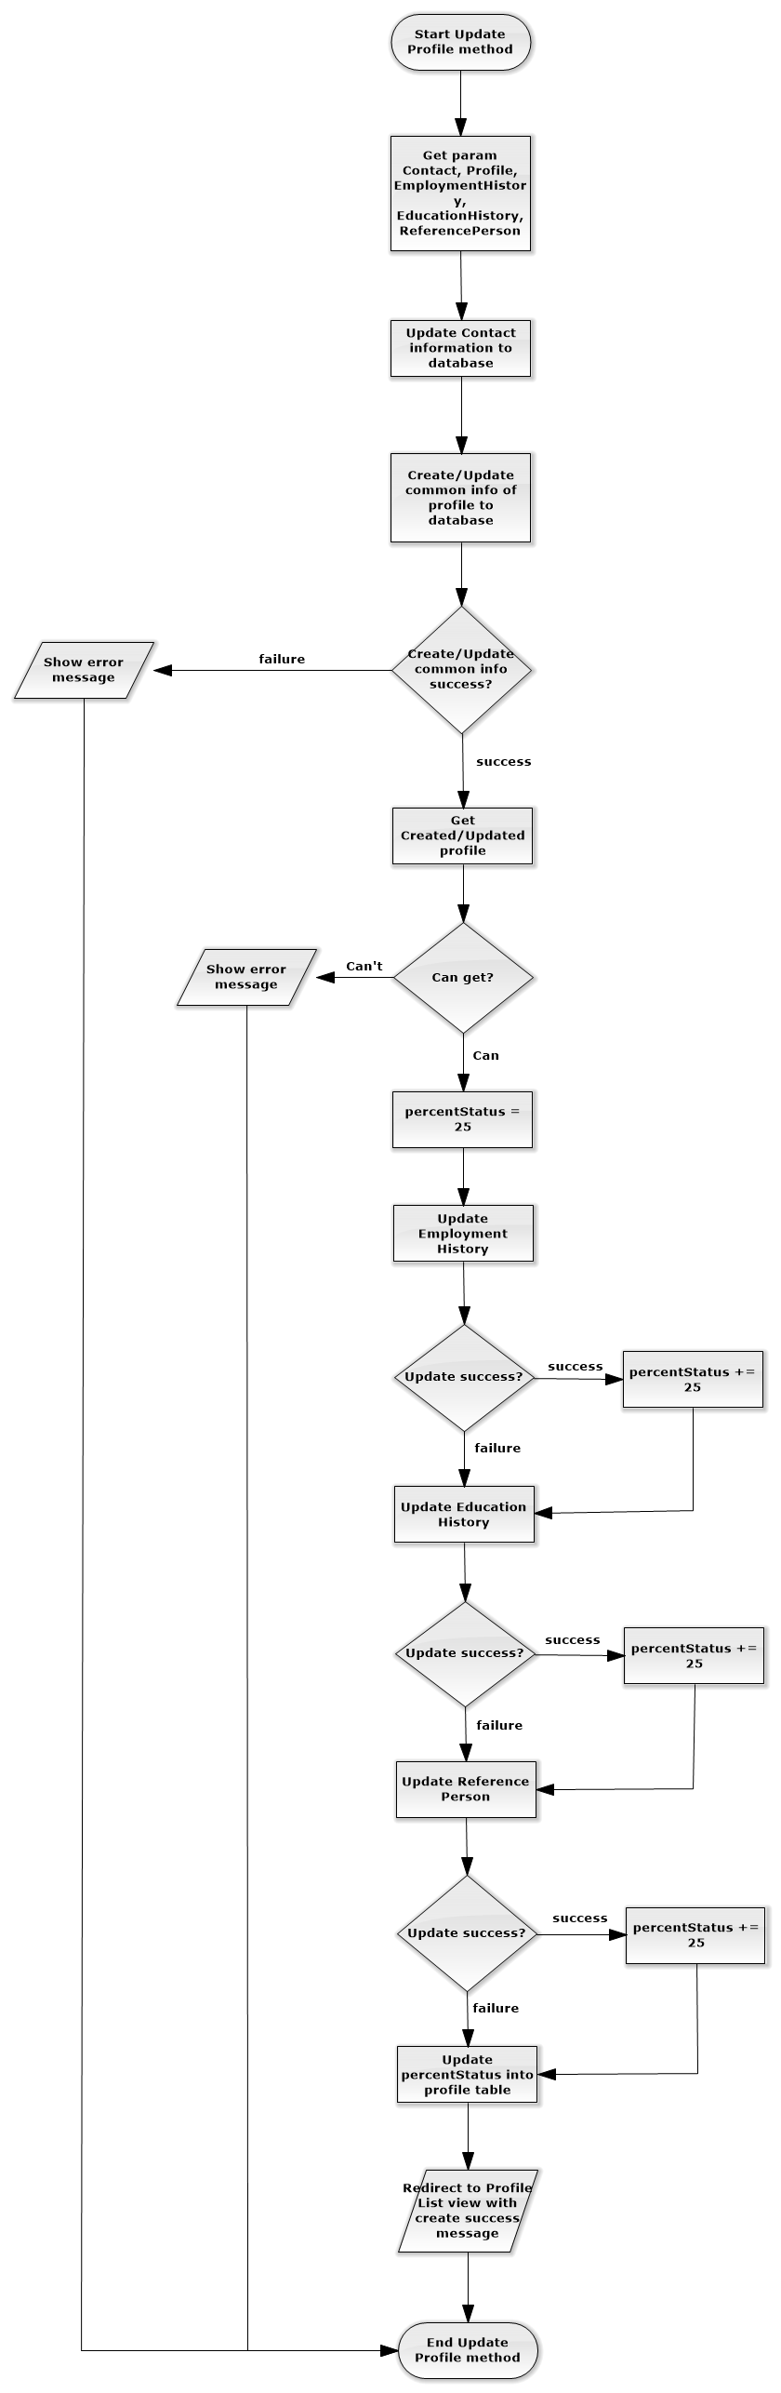

### 4.4.2. DAL – Data Access Layer

#### 4.4.2.1.Class Diagram

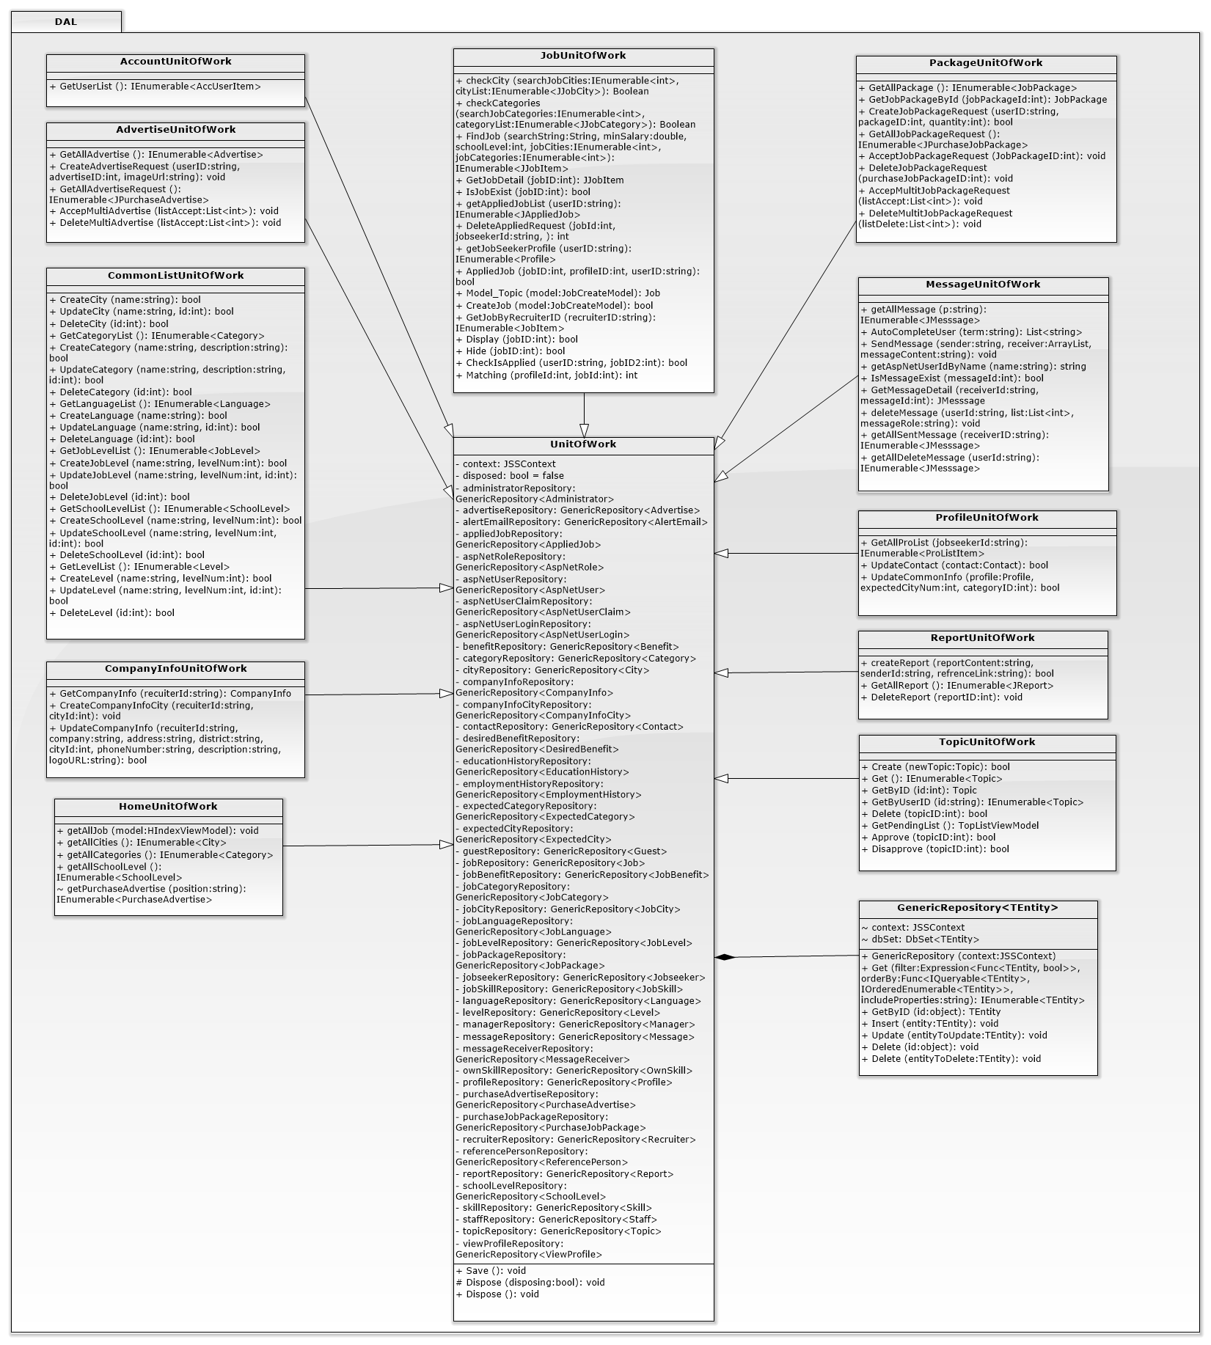

Figure 4. 4 – DAL Class Diagram

#### 4.4.2.2. Class Diagram Explanation

The class which handle directly to single table in database is GenericRepository.

UnitOfWork class colect all single Repository to manage them easier, avoid a lot of unnecessary conficts.

Each other UnitOfWork is inherited and named with format “Entity’s name” as the prefix and “UnitOfWork” corresponding to each Controller. They do all database processing method for Controllers.

#### 4.4.2.3. Algorithms of important methods, specified by Flow-Chart

##### 4.4.2.3.1. JobUnitOfWork/FindJob

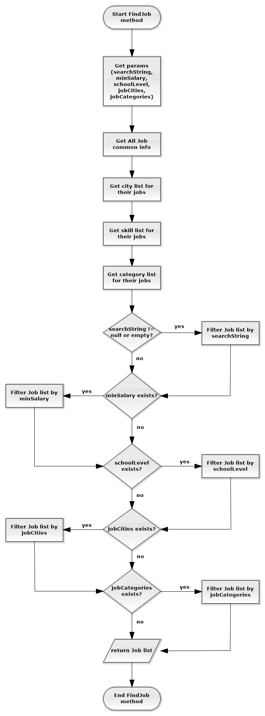

##### 4.4.2.3.2. JobUnitOfWork/Matching

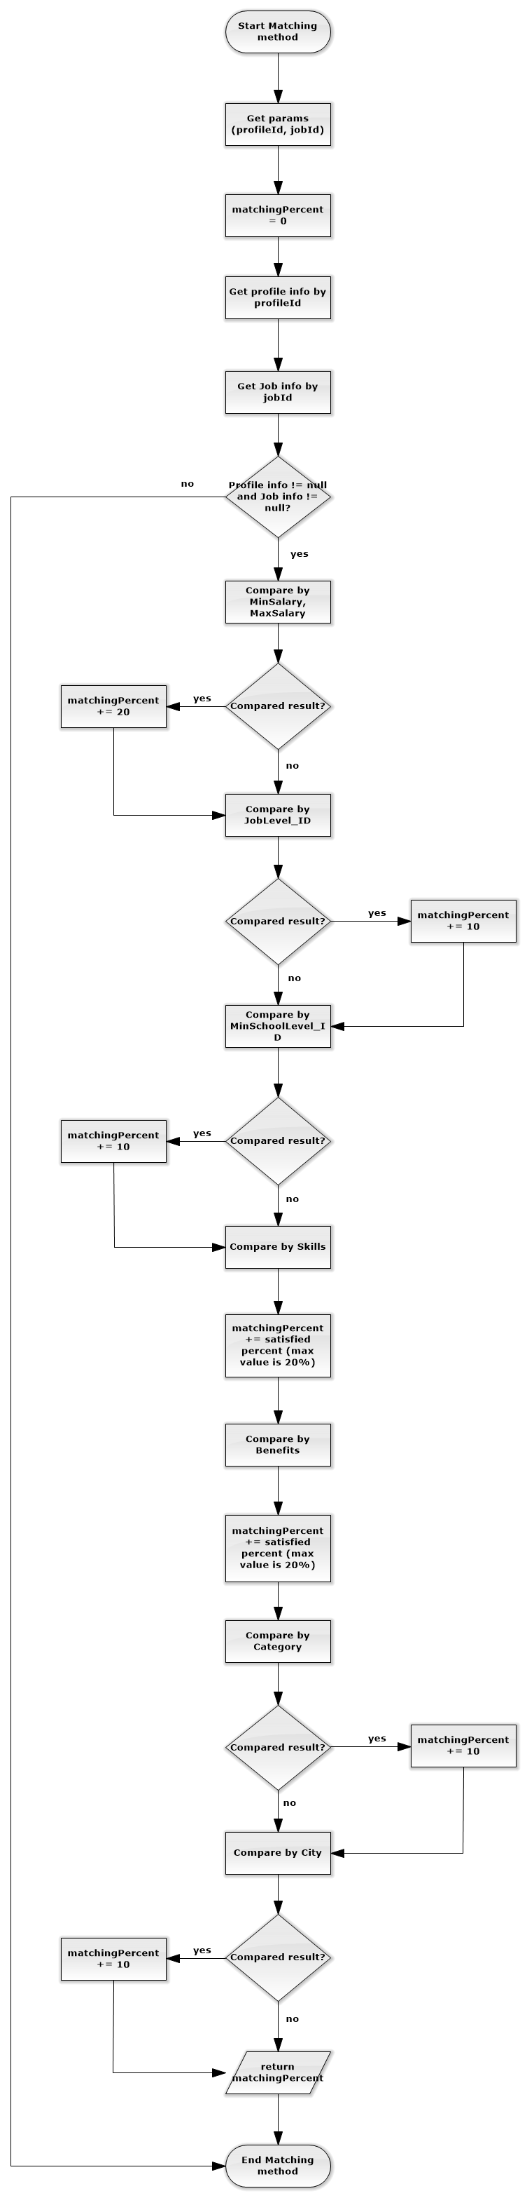

##### 4.4.2.3.3. ProfileUnitOfWork/UpdateCommonInfo

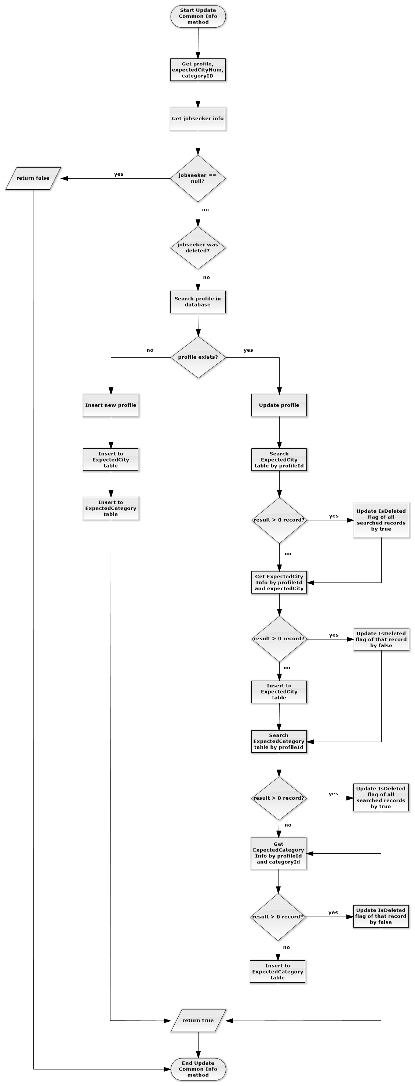

## 4.5. Sequence Diagram

### 4.5.1. Create Job

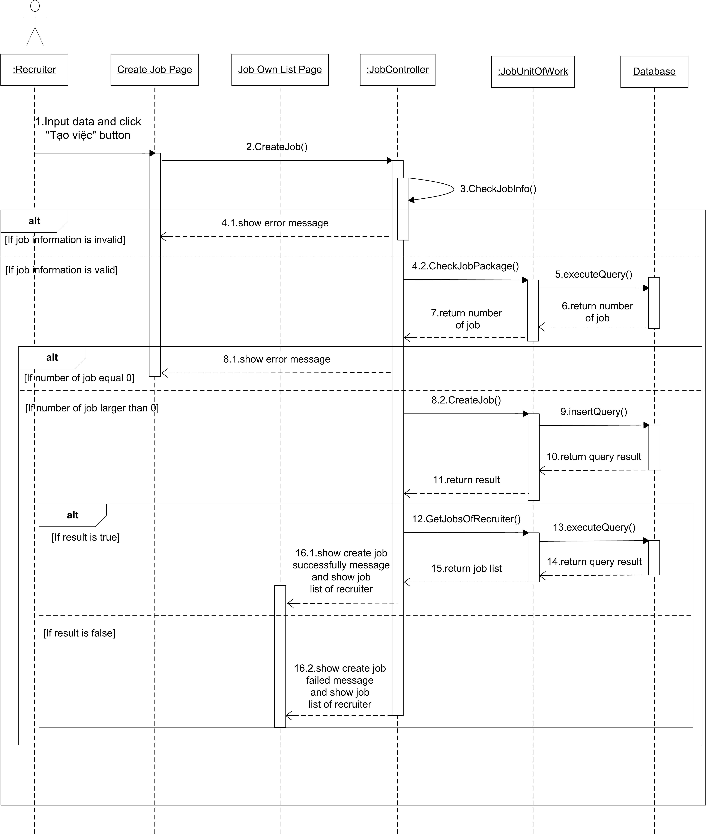

Figure 4. 5 – Create Job Sequence diagram

### 4.5.2. Find Job

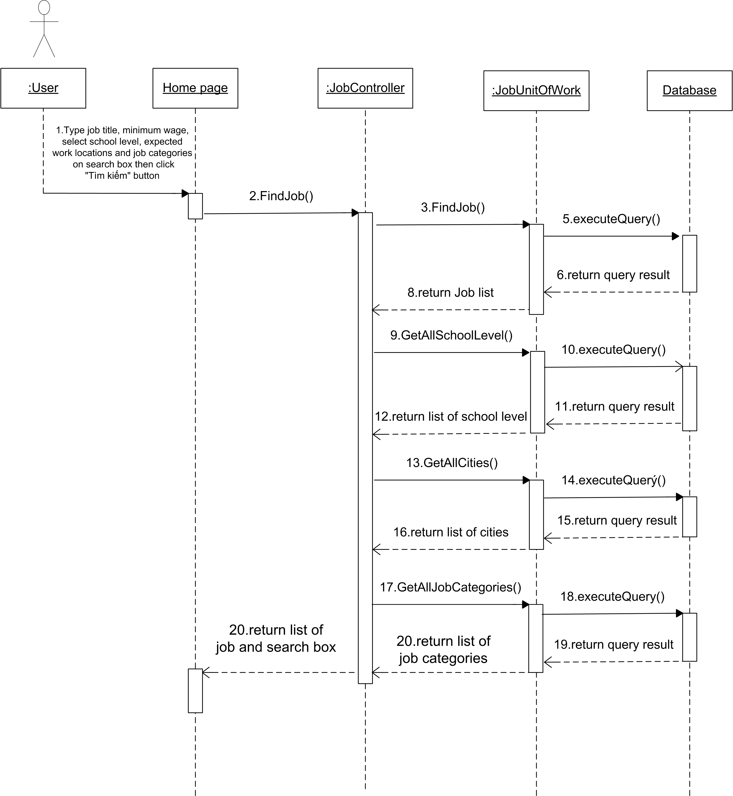

Figure 4. 6 – Find Job Sequence diagram

### 4.5.3. Apply Job

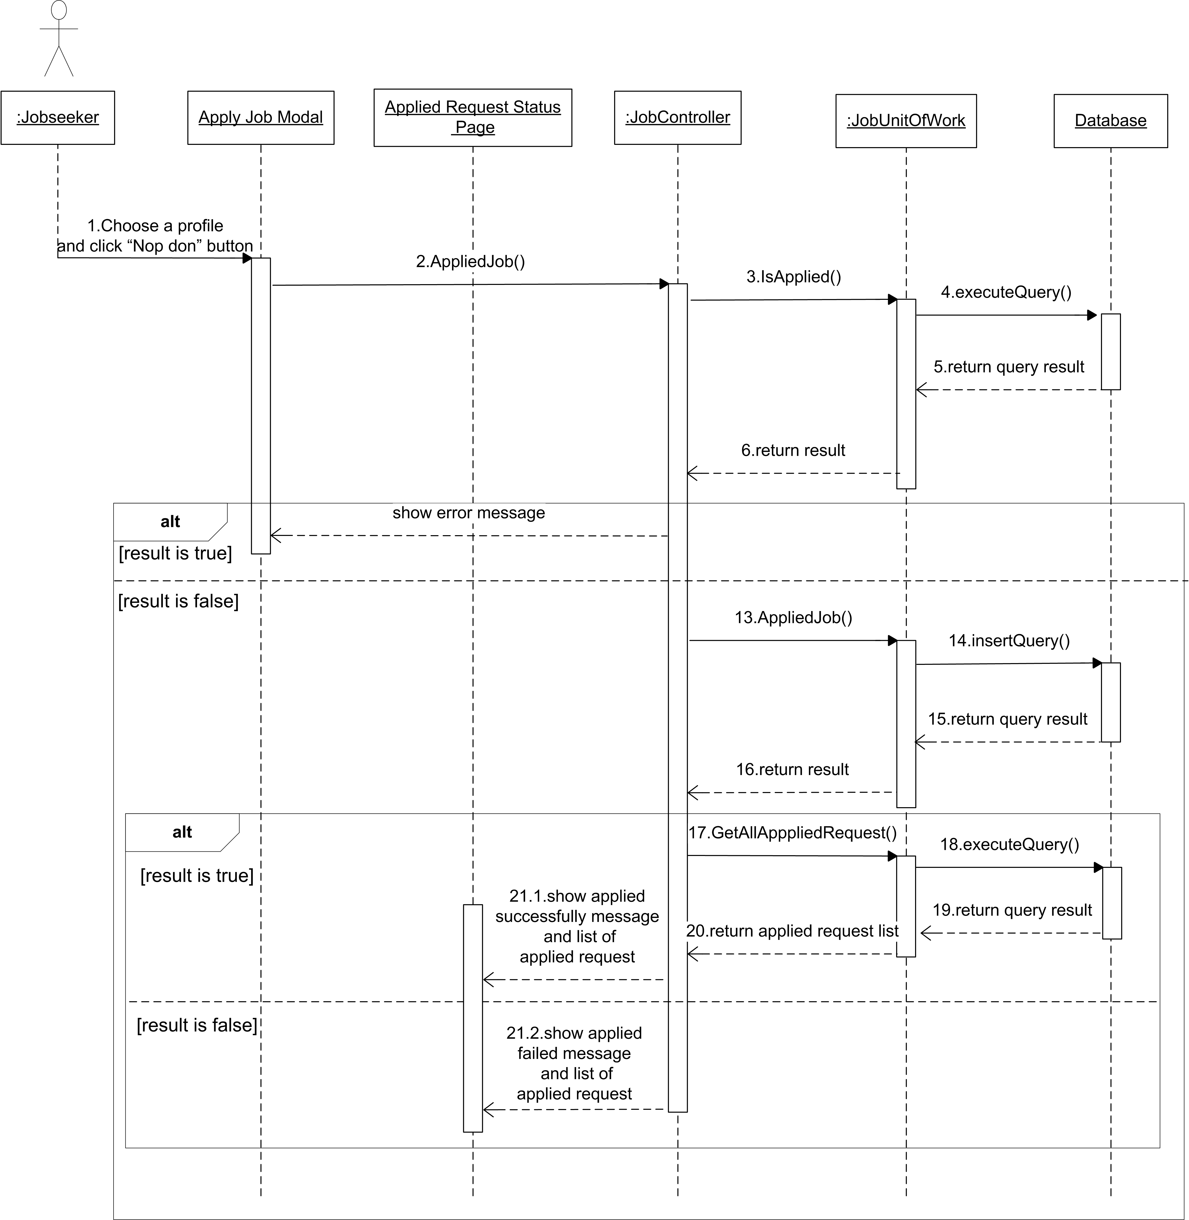

Figure 4. 7 – Apply Job Sequence diagram

### 4.5.4. Create Message

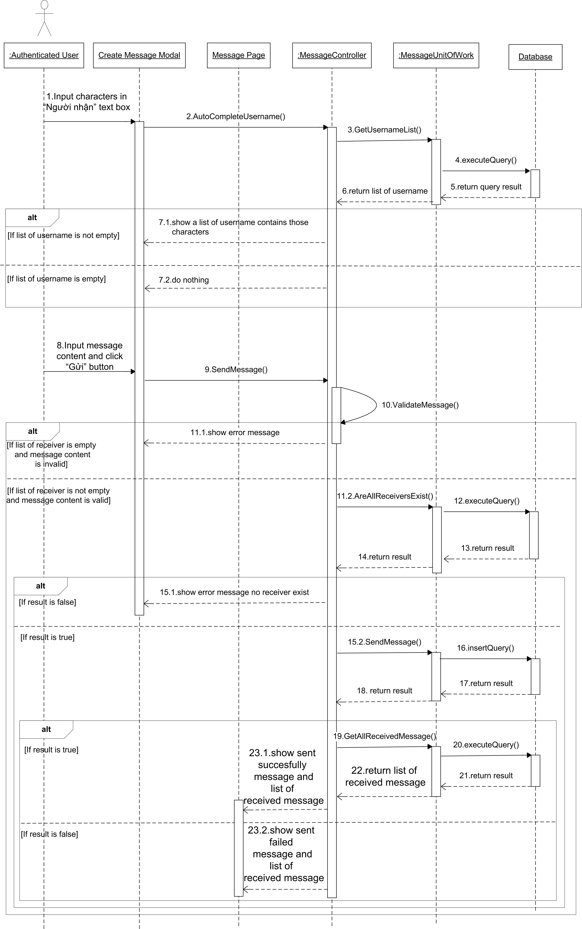

Figure 4. 8 – Create Message Sequence diagram

## 4.6. User Interface Design

### 4.6.1. HomeController

#### 4.6.1.1. Index

##### 4.6.1.1.1. Screen

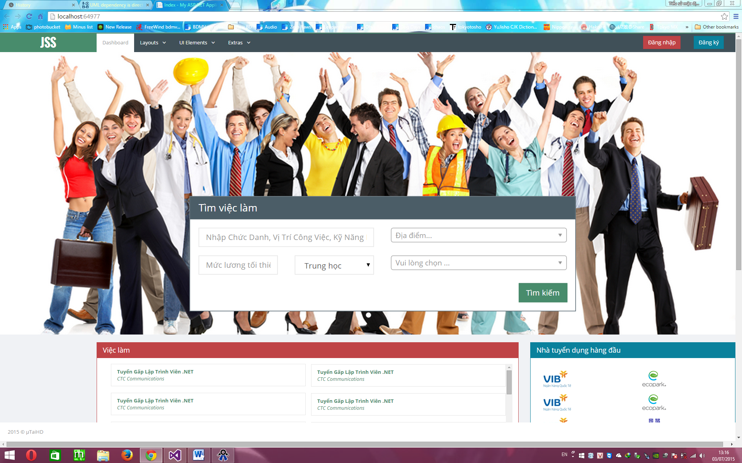

##### 4.6.1.1.2. Description

|  |  |  |  |  |  |  |
| --- | --- | --- | --- | --- | --- | --- |
| **No** | **Object Control Name** | **Object/ Control Name in English** | **Type** | **Required** | **Length** | **Description** |
| 1 | Tên công việc | Job Name | Text | Y | 50 | Input the job’s name. |
| 2 | Mức lương | Salary | Text | N/A | N/A | Input the lowest desired salary or blank information. |
| 3 | Trình độ | Level | DropDownList | N/A | N/A | Choose the level required for the job. |
| 4 | Địa điểm | Location | DropDownList | N/A | N/A | Choose the location required for the job (max 3 locations). |
| 5 | Ngành nghề | Job Category | DropDownList | N/A | N/A | Choose the job category. |
| 6 | Tìm kiếm | Search | Button | Y | N/A | Click on button to start searching job. |
| 7 | Việc làm | Job | Text | N/A | N/A | Click on any job showed to get that job’s information. |
| 8 | Nhà tuyển dụng hàng đầu | Best Recruiter | Image | N/A | N/A | Click on any logo showed to get the company’s information. |
| 9 | JSS | Home | Button | N/A | N/A | Click on button to redirect user to the home page |
| 10 | Đăng nhập | LogIn | Button | N/A | N/A | Click on button to open the SignIn window. |
| 11 | Đăng ký | Register | Button | N/A | N/A | Click on button to open the Register window. |

### 4.6.2. AccountController

#### 4.6.2.1. Login

##### 4.6.2.1.1. Screen

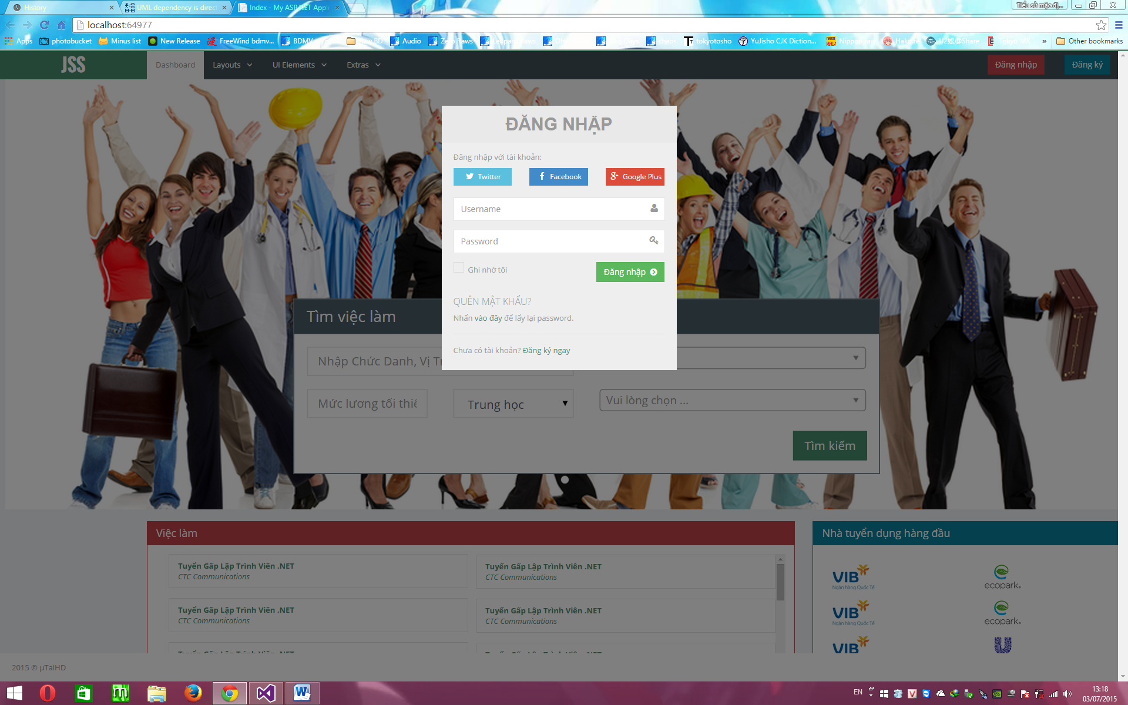

##### 4.6.2.1.2. Description

|  |  |  |  |  |  |  |
| --- | --- | --- | --- | --- | --- | --- |
| **No** | **Object Control Name** | **Object/ Control Name in English** | **Type** | **Required** | **Length** | **Description** |
| 1 | Twister | Twister | Button | N/A | N/A | Click on button to use the Twister account to sign in. |
| 2 | Facebook | Facebook | Button | N/A | N/A | Click on button to use the Facebook account to sign in. |
| 3 | Google Plus | Google Plus | Button | N/A | N/A | Click on button to use the Google Plus account to sign in. |
| 4 | Tên đăng nhập | Username | Text | Y | 50 | Input the account’s username. |
| 5 | Mật khẩu | Password | Text | Y | 50 | Input the account’s password. |
| 6 | Ghi nhớ tôi | Remember Account | CheckBox | N/A | N/A | Click on check box to remember username & password for this website. |
| 7 | Đăng nhập | SignIn | Button | Y | N/A | Click on button to sign in. |
| 8 | Vào đây | Forget Password | Text | N/A | N/A | Click on this text to open the GetNewPassword window. |
| 9 | Đăng ký ngay | Register | Text | N/A | N/A | Click on this text to open the Register window. |

### 4.6.3. ApplicantController

#### 4.6.3.1. List

##### 4.6.3.1.1. Screen

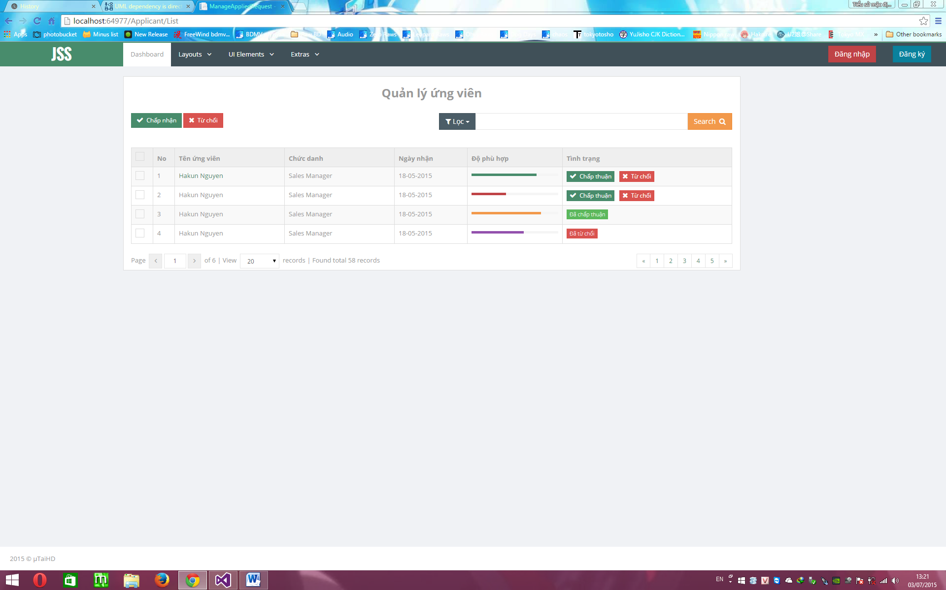

##### 4.6.3.1.2. Description

|  |  |  |  |  |  |  |
| --- | --- | --- | --- | --- | --- | --- |
| **No** | **Object Control Name** | **Object/ Control Name in English** | **Type** | **Required** | **Length** | **Description** |
| 1 | Lọc | Filter | Button | N/A | N/A | Click on button to filter information want to search. |
| 2 | No | No. | Label | N/A | N/A | This label show the number joobseeke applied. |
| 3 | Tên ứng viên | Name | Label | N/A | N/A | This label show joobseeker’s name applied. |
| 4 | Chức danh | Position | Label | N/A | N/A | This label show the position jobseeker want to work. |
| 5 | Ngày nhận | DateTime | Label | N/A | N/A | This label show the date applied the request from jobseeker. |
| 6 | Độ phù hợp | Relevance | Label | N/A | N/A | This label show the percent relevance of request for the job. |
| 7 | Tình trạng | Status | Label | N/A | N/A | Show the status of the request. |
| 8 | Check | Check Job | CheckBox | N/A | N/A | Click to check/uncheck the job to accept or deny. |
| 9 | Chấp nhận | Accept | Button | N/A | N/A | Click on button to accept multi request checked on check box label. |
| 10 | Từ chối | Deny | Button | N/A | N/A | Click on button to accept multi request checked on check box label. |
| 11 | Page move forward | Page move forward | Button | N/A | N/A | Click on button to move to the next page. |
| 12 | Page move backward | Page move backward | Button | N/A | N/A | Click on button to move to the previous page. |
| 13 | View | View | DropdownList | N/A | N/A | Choose the number of request want to show on each page. |

### 4.6.4. JobController

#### 4.6.4.1. Find

##### 4.6.4.1.1. Screen

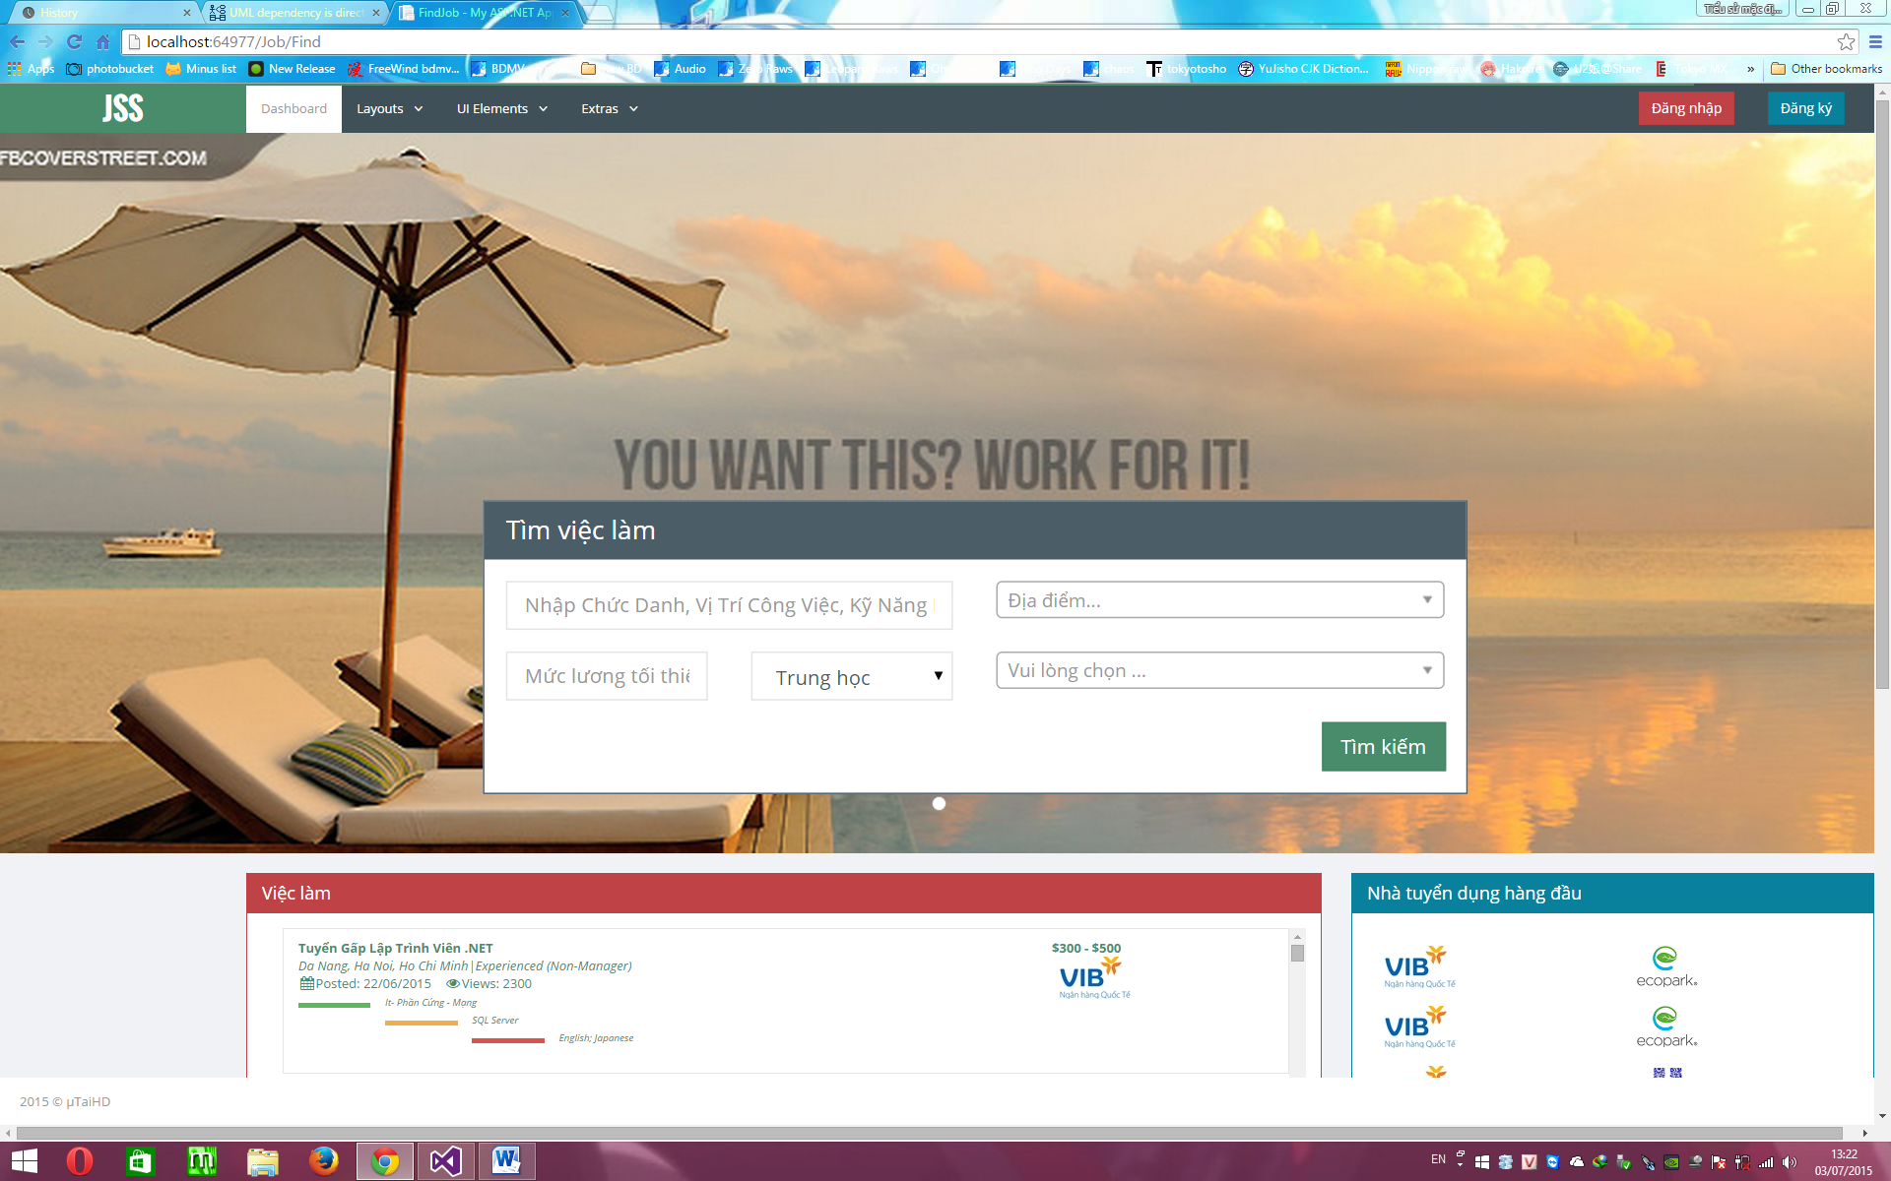

##### 4.6.4.1.2. Description

|  |  |  |  |  |  |  |
| --- | --- | --- | --- | --- | --- | --- |
| **No** | **Object Control Name** | **Object/ Control Name in English** | **Type** | **Required** | **Length** | **Description** |
| 1 | Tên công việc | Job Name | Text | Y | 50 | Input the job’s name. |
| 2 | Mức lương | Salary | Text | N/A | N/A | Input the lowest desired salary or blank information. |
| 3 | Trình độ | Level | DropDownList | N/A | N/A | Choose the level required for the job. |
| 4 | Địa điểm | Location | DropDownList | N/A | N/A | Choose the location required for the job (max 3 locations). |
| 5 | Ngành nghề | Job Category | DropDownList | N/A | N/A | Choose the job category. |
| 6 | Tìm kiếm | Search | Button | Y | N/A | Click on button to start searching job. |

#### 4.6.4.2. Create

##### 4.6.4.2.1. Screen

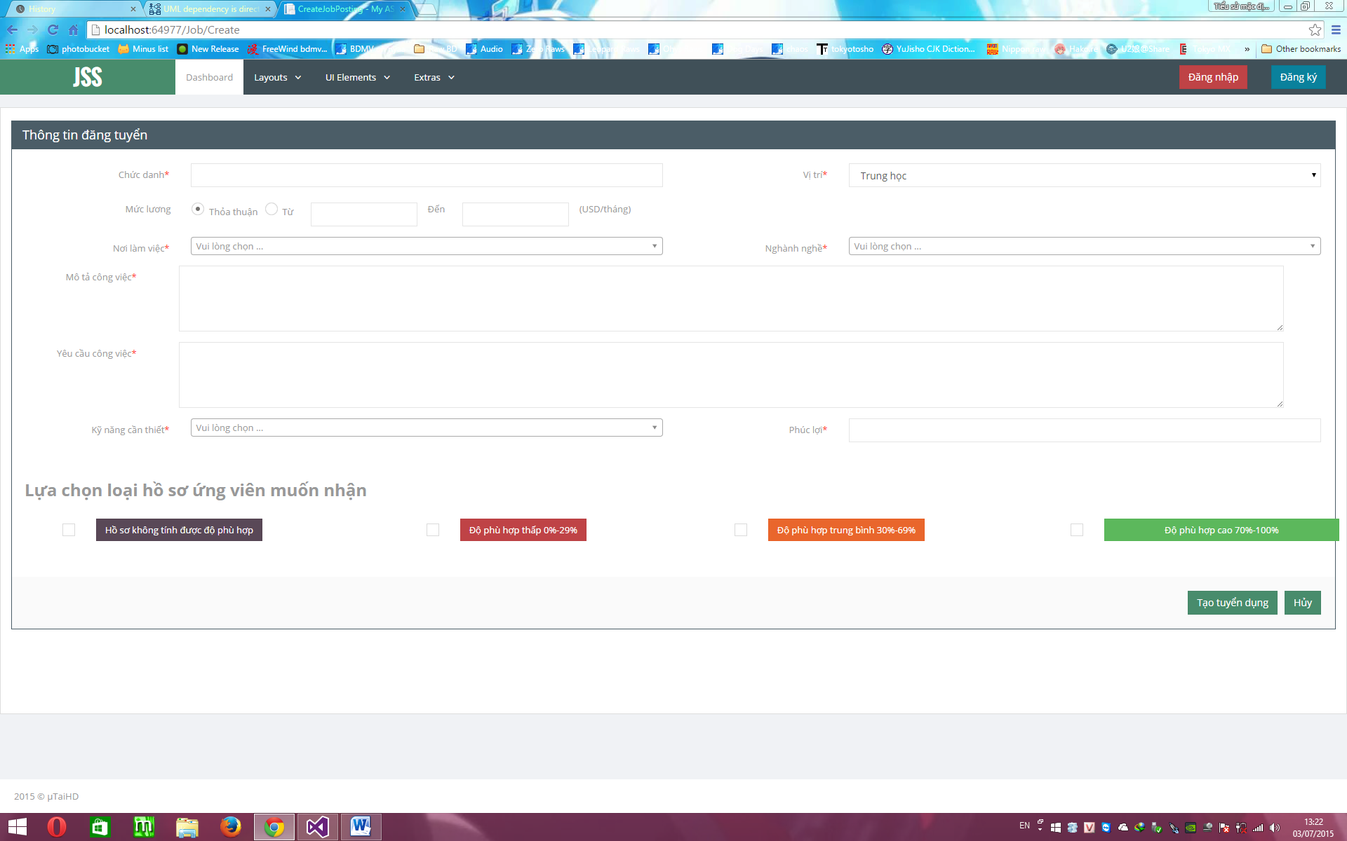

##### 4.6.4.2.2. Description

|  |  |  |  |  |  |  |
| --- | --- | --- | --- | --- | --- | --- |
| **No** | **Object Control Name** | **Object/ Control Name in English** | **Type** | **Required** | **Length** | **Description** |
| 1 | Chức danh | Position | Text | Y | 50 | Input the job’s position. |
| 2 | Mức lương | Salary | Text/CheckBox | N/A | N/A | Input the range of salary or choose “Thỏa thuận” check box. |
| 3 | Trình độ | Level | DropDownList | Y | N/A | Choose the level required for the job. |
| 4 | Nơi Làm Việc | Location | DropDownList | Y | N/A | Choose the location required for the job (max 3 locations). |
| 5 | Ngành nghề | Job Category | DropDownList | Y | N/A | Choose the job category. |
| 6 | Yêu cầu công việc | Job’s Requirement | Text | Y | 500 | Input the job’ requirement. |
| 7 | Kỹ năng cần thiết | Job’s Skill | DropDownList | Y | N/A | Choose the skill needed for the job. |
| 8 | Phúc lợi | Job’s Benefit | Text | Y | 50 | Input the benefit when doing this job. |
| 10 | Tạo tuyển dụng | Create Job | Button | Y | N/A | Click on button to create a new job. |
| 11 | Hủy | Cancel | Button | N/A | N/A | Cancel create job. |

#### 4.6.4.3. Detail

##### 4.6.4.3.1. Screen

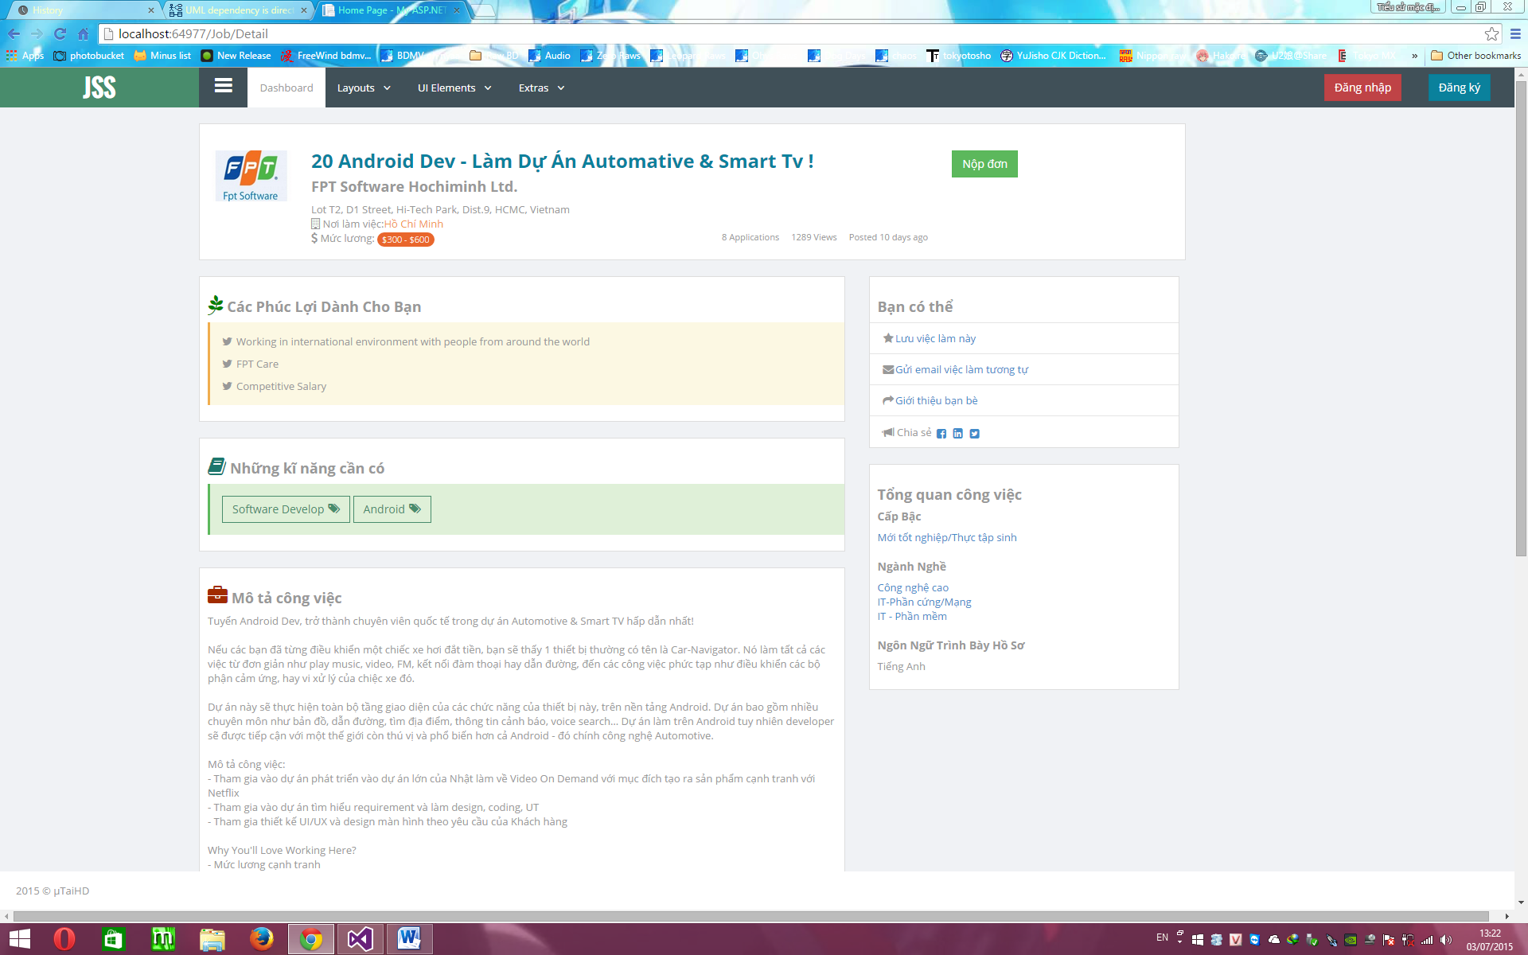

##### 4.6.4.3.2. Description

|  |  |  |  |  |  |  |
| --- | --- | --- | --- | --- | --- | --- |
| **No** | **Object Control Name** | **Object/ Control Name in English** | **Type** | **Required** | **Length** | **Description** |
| 1 | Nộp đơn | Apply Job | Button | N/A | N/A | Click on button to send request to recruiter that you want to apply for this job. |
| 2 | Job’ infor | Job Infor | Text | N/A | N/A | Show the job’s name, location, salary. |
| 3 | Các phúc lợi dành cho bạn | Job Benefit | Text | N/A | N/A | Show job’s benefit. |
| 4 | Những kỹ năng cần có | Job Skill | Text | N/A | N/A | Show job’s skill needed. |
| 5 | Mô tả công việc | Job Description | Text | N/A | N/A | Show job’s description. |
| 6 | Tổng quan công việc | Job OverView | Text | N/A | N/A | Show job’s level needed, Job category, language for profile. |
| 7 | Lưu việc làm này | Save Job | Text | N/A | N/A | Click to save this job on AppliedJobList to review later. |
| 8 | Gửi email việc làm tương tự |  | Text | N/A | N/A |  |
| 10 | Giới thiệu bạn bè | Share With Friend | Text | N/A | N/A | Click to share this job with friends. |
| 11 | Chia sẻ | Share | Button | N/A | N/A | Click on any button to share this job on Facebook, twister, Google Plus. |

#### 4.6.4.4. OwnList

##### 4.6.4.4.1. Screen

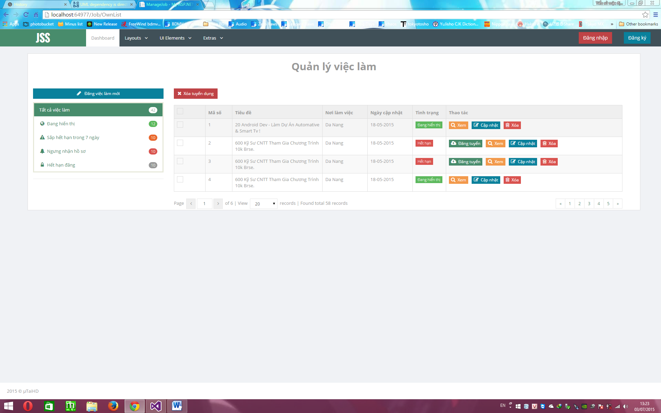

##### 4.6.4.4.2. Description

|  |  |  |  |  |  |  |
| --- | --- | --- | --- | --- | --- | --- |
| **No** | **Object Control Name** | **Object/ Control Name in English** | **Type** | **Required** | **Length** | **Description** |
| 1 | Đăng việc làm mới | Create New Job | Button | N/A | N/A | Click to open CreateJob page. |
| 2 | Xóa tuyển dụng | Delete Job | Button | N/A | N/A | Click to delete multi job checked on checkbox label |
| 3 | Check Job | Check Job | Label | N/A | N/A | Click to check/uncheck the job to delete. |
| 4 | Mã số | No | Label | N/A | N/A | Show the number of job created. |
| 5 | Tiêu đề | Job’s Name | Label | N/A | N/A | Show the name of the job created. |
| 6 | Nơi làm việc | Job’s Location | Label | N/A | N/A | Show the location the job required. |
| 7 | Ngày cập nhật | DateTime | Label | N/A | N/A | Show the time created the job. |
| 8 | Tình trạng | Job Status | Label | N/A | N/A | Show the job’ status. |
| 9 | Thao tác | Action | Label | N/A | N/A | Show actions for that job. |
| 10 | Xem | View | Button | N/A | N/A | Click on button to view the job’s information in the new tab. |
| 11 | Cập nhật | Update | Button | N/A | N/A | Click on button to update the job’s information in the new tab. |
| 12 | Xóa | Delete | Button | N/A | N/A | Click on button to delete that job. |
| 13 | Filter | FIlter |  | N/A | N/A | Show all the filer to search. |
| 14 | Tất cả việc làm | All Job Filter | Button | N/A | N/A | Show all the job created. |
| 15 | Đang hiển thị | Job Showing Filter | Button | N/A | N/A | Show all the job with status “Đang hiển thị”. |
| 16 | Sắp hết hạn trong 7 ngày | Job Expiring Filter | Button | N/A | N/A | Show all the job with status “Sắp hết hạn trong 7 ngày”. |
| 17 | Ngưng nhận hồ sơ | Job Stop receiving profile Filter | Button | N/A | N/A | Show all the job with status “Ngưng nhận hồ sơ”. |
| 18 | Hết hạn đăng | Job Expried Filter | Button | N/A | N/A | Show all the job with status “Hết hạn ”. |
| 19 | Page move forward | Page move forward | Button | N/A | N/A | Click on button to move to the next page. |
| 20 | Page move backward | Page move backward | Button | N/A | N/A | Click on button to move to the previous page. |

#### 4.6.4.5. AppliedJobList

##### 4.6.4.5.1. Screen

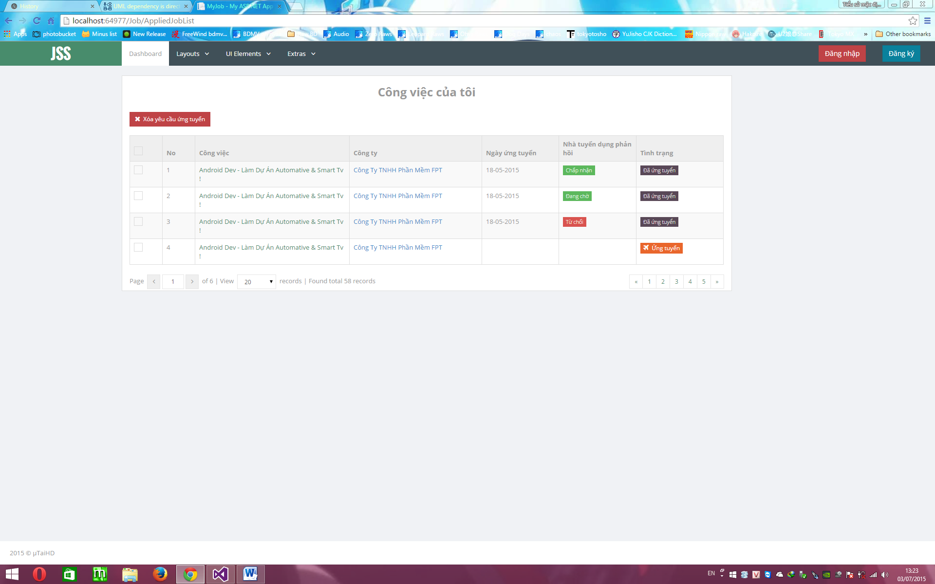

##### 4.6.4.5.2. Description

|  |  |  |  |  |  |  |
| --- | --- | --- | --- | --- | --- | --- |
| **No** | **Object Control Name** | **Object/ Control Name in English** | **Type** | **Required** | **Length** | **Description** |
| 1 | Xóa yêu cầu tuyển dụng | Delete Job Applied | Button | N/A | N/A | Click on button to delete multi applied job checked on check box label. |
| 2 | Check Job | Check Job | Label | N/A | N/A | Click to check/uncheck the applied job to delete. |
| 3 | No | No | Label | N/A | N/A | Click to check/uncheck the applied job for delete. |
| 4 | Công việc | Job’s Name | Label | N/A | N/A | Show the applied job’ name. Click on any job’s name to show the job information in the new tab. |
| 5 | Công ty | Job’ Company | Label | N/A | N/A | Show the applied job’s company. Click on any job’s company to show the company’s information in the new tab. |
| 6 | Ngày ứng tuyển | DateTime Applied | Label | N/A | N/A | Show the date time applied that job. |
| 7 | Nhà tuyển dụng phản hồi | Response From Recruiter | Label | N/A | N/A | Show the response status |
| 8 | Tình trạng | Job Applied Status | Label | N/A | N/A | Show the status of that applied job. |
| 9 | Page move forward | Page move forward | Button | N/A | N/A | Click on button to move to the next page. |
| 10 | Page move backward | Page move backward | Button | N/A | N/A | Click on button to move to the previous page. |
| 11 | View | View | DropdownList | N/A | N/A | Choose the number of applied job want to show on each page. |

### 4.6.5. JobPackageController

#### 4.6.5.1. Choose

##### 4.6.5.1.1. Screen

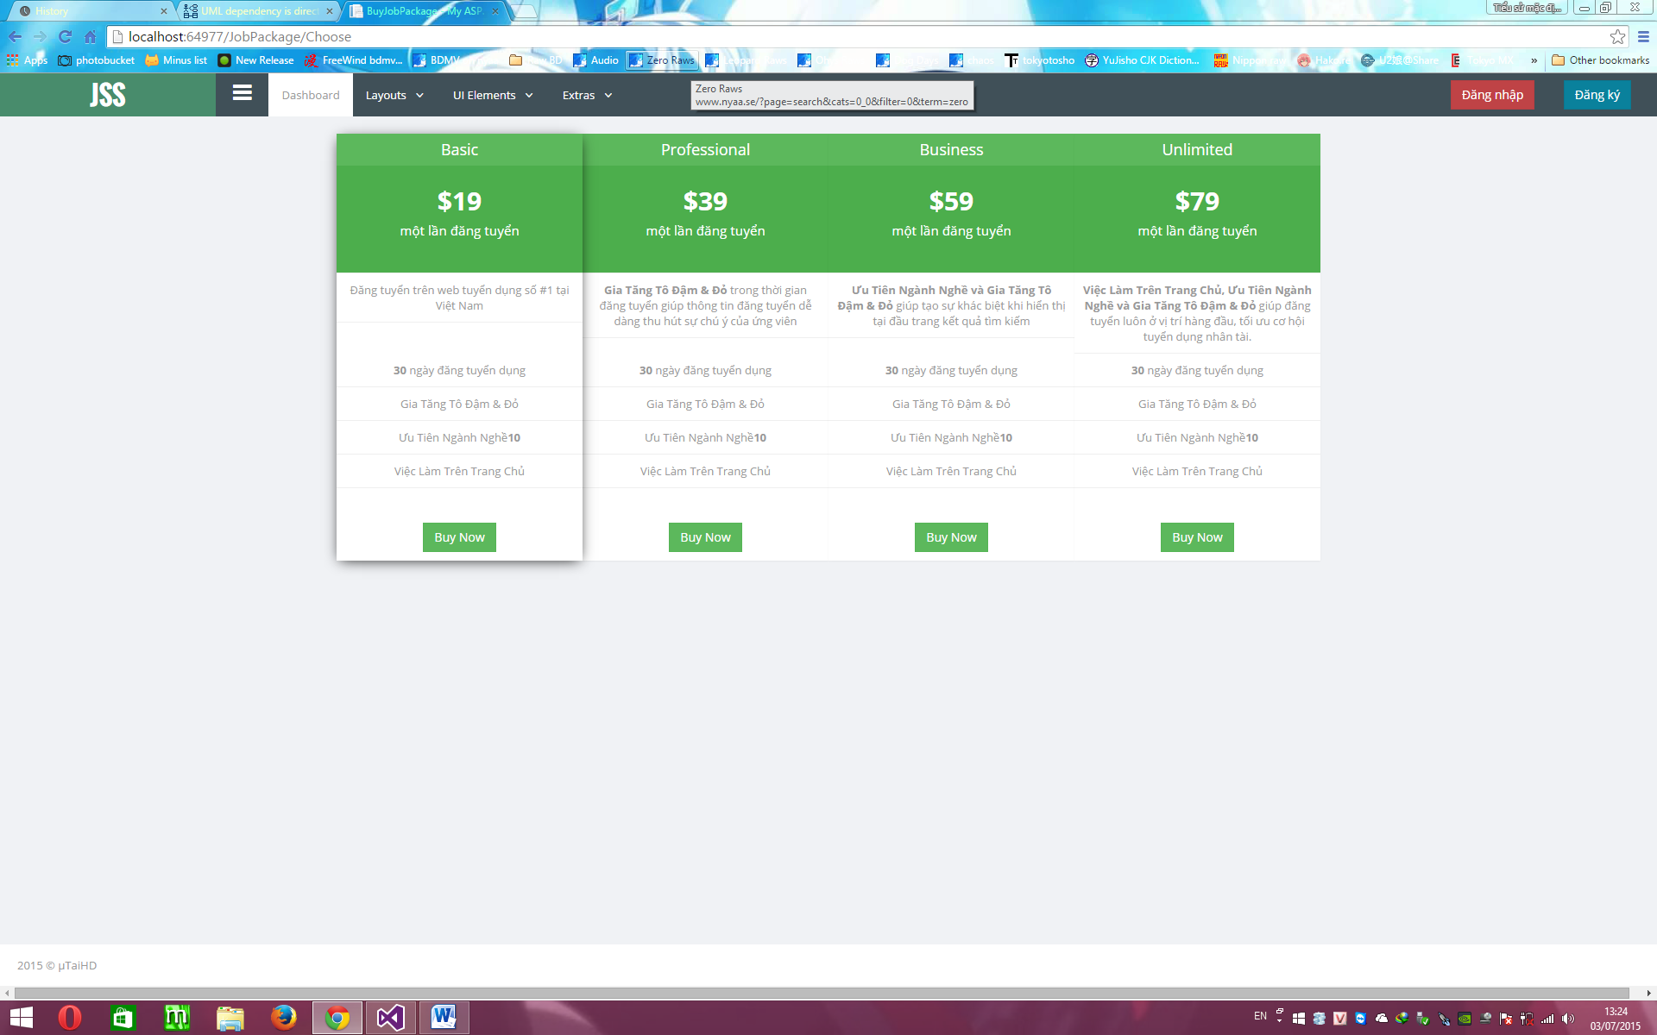

##### 4.6.5.1.2. Description

|  |  |  |  |  |  |  |
| --- | --- | --- | --- | --- | --- | --- |
| **No** | **Object Control Name** | **Object/ Control Name in English** | **Type** | **Required** | **Length** | **Description** |
| 1 | Basic | Basic | Text | N/A | N/A | Show the information of the Basic job package. |
| 2 | Professional | Professional | Text | N/A | N/A | Show the information of the Professional job package. |
| 3 | Business | Business | Text | N/A | N/A | Show the information of the Business job package. |
| 4 | Unlimited | Unlimited | Text | N/A | N/A | Show the information of the Unlimited job package. |
| 5 | Buy Now | Buy | Button | N/A | N/A | Click on button below any job package to buy that job package. Show Invoice page in new tab. |

#### 4.6.5.2. Invoice

##### 4.6.5.2.1. Screen

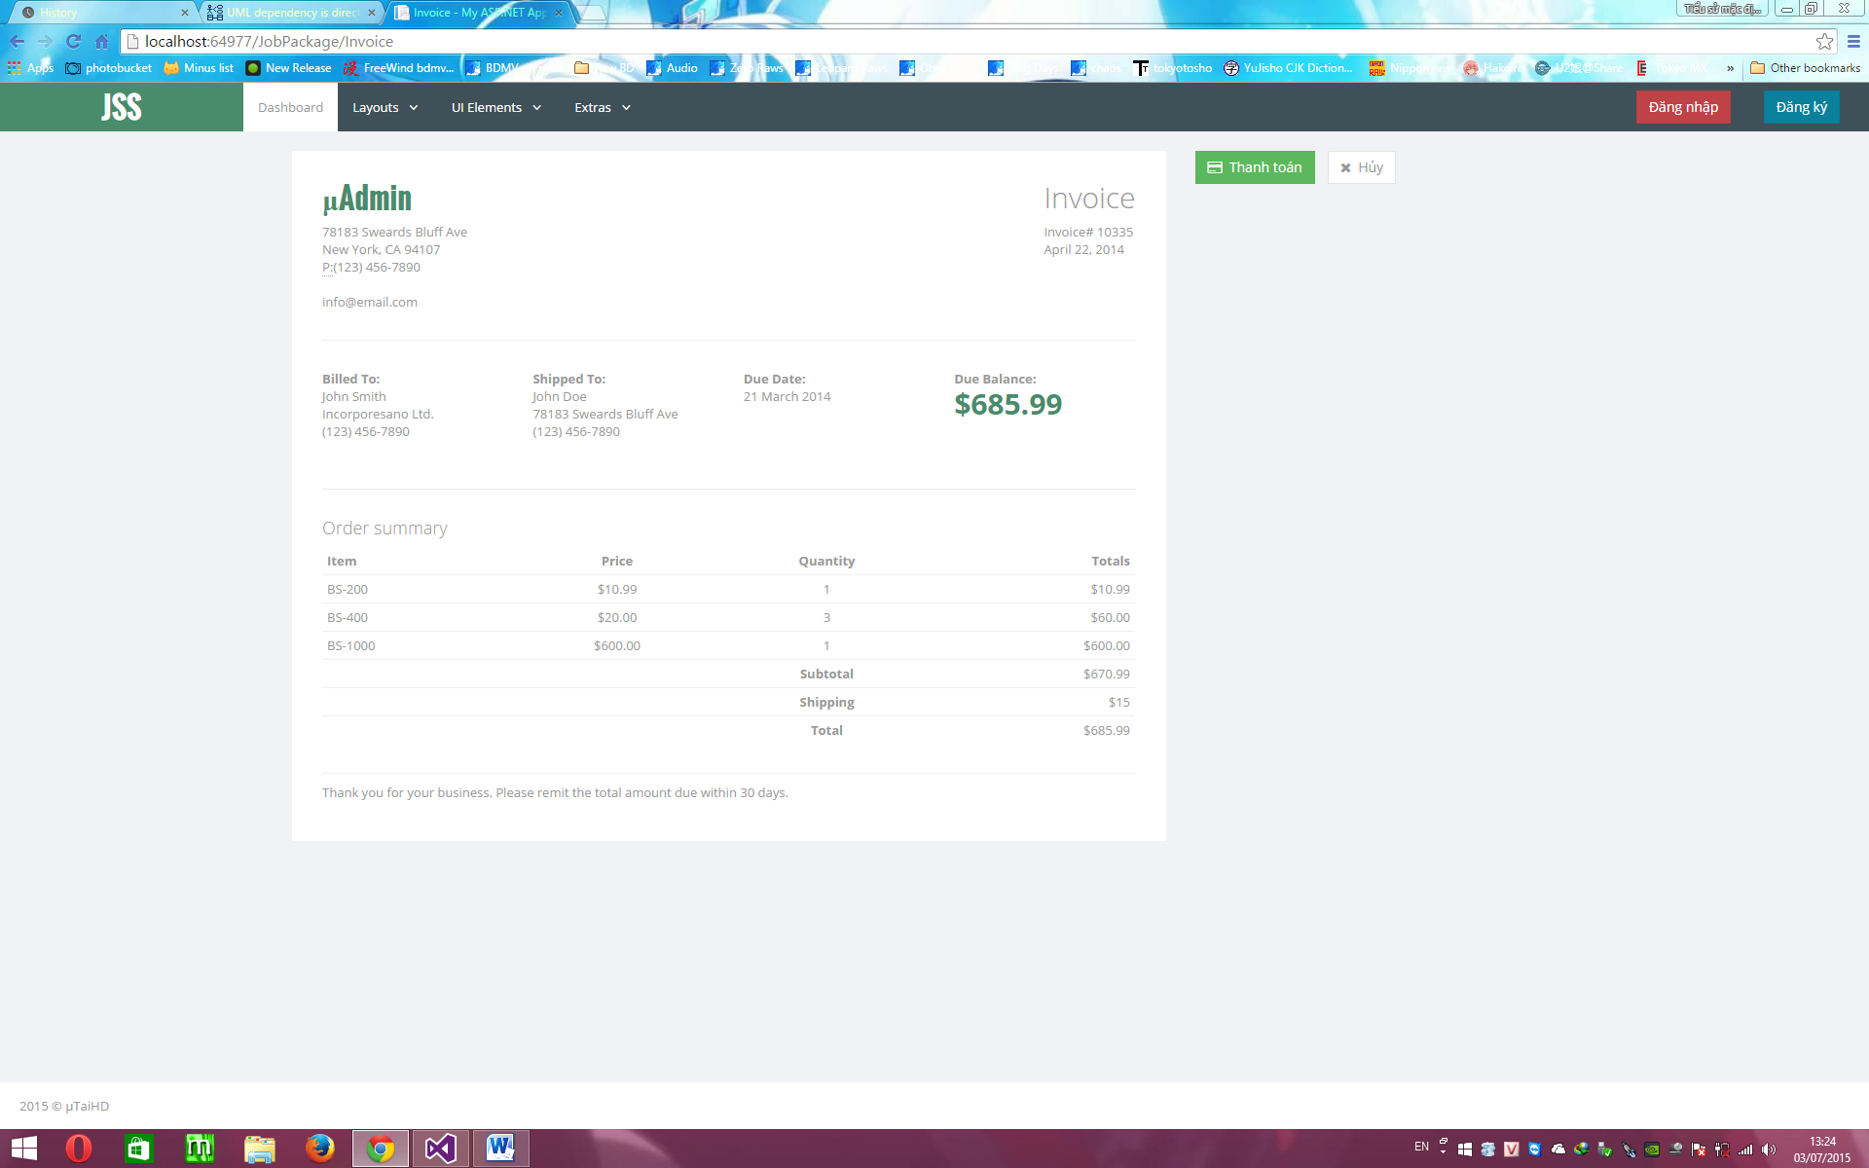

##### 4.6.5.2.2. Description

|  |  |  |  |  |  |  |
| --- | --- | --- | --- | --- | --- | --- |
| **No** | **Object Control Name** | **Object/ Control Name in English** | **Type** | **Required** | **Length** | **Description** |
| 1 | Account Infor | Account Infor | Text | N/A | N/A | Show account’s information. |
| 2 | Due Balance | Due Balance | Text | N/A | N/A | Show the account’s balance. |
| 3 | Due Date | Due Date | Text | N/A | N/A | Show the date time. |
| 4 | Billed To | Billed | Text | N/A | N/A | Show the sender information. |
| 5 | Shipped | Shipped | Text | N/A | N/A | Show the receiver information. |
| 6 | Order Summary | Order Summary | Text | N/A | N/A | Show all the information of previous order (Item, Price, Quantity, Totals). |
| 7 | Thanh toán | Payment | Button | N/A | N/A | Click on button to pay money for that job package. |
| 8 | Hủy | Cancel | Button | N/A | N/A | Click on button to cancel this action. |

### 4.6.6. MessageController

#### 4.6.6.1. Inbox

##### 4.6.6.1.1. Screen

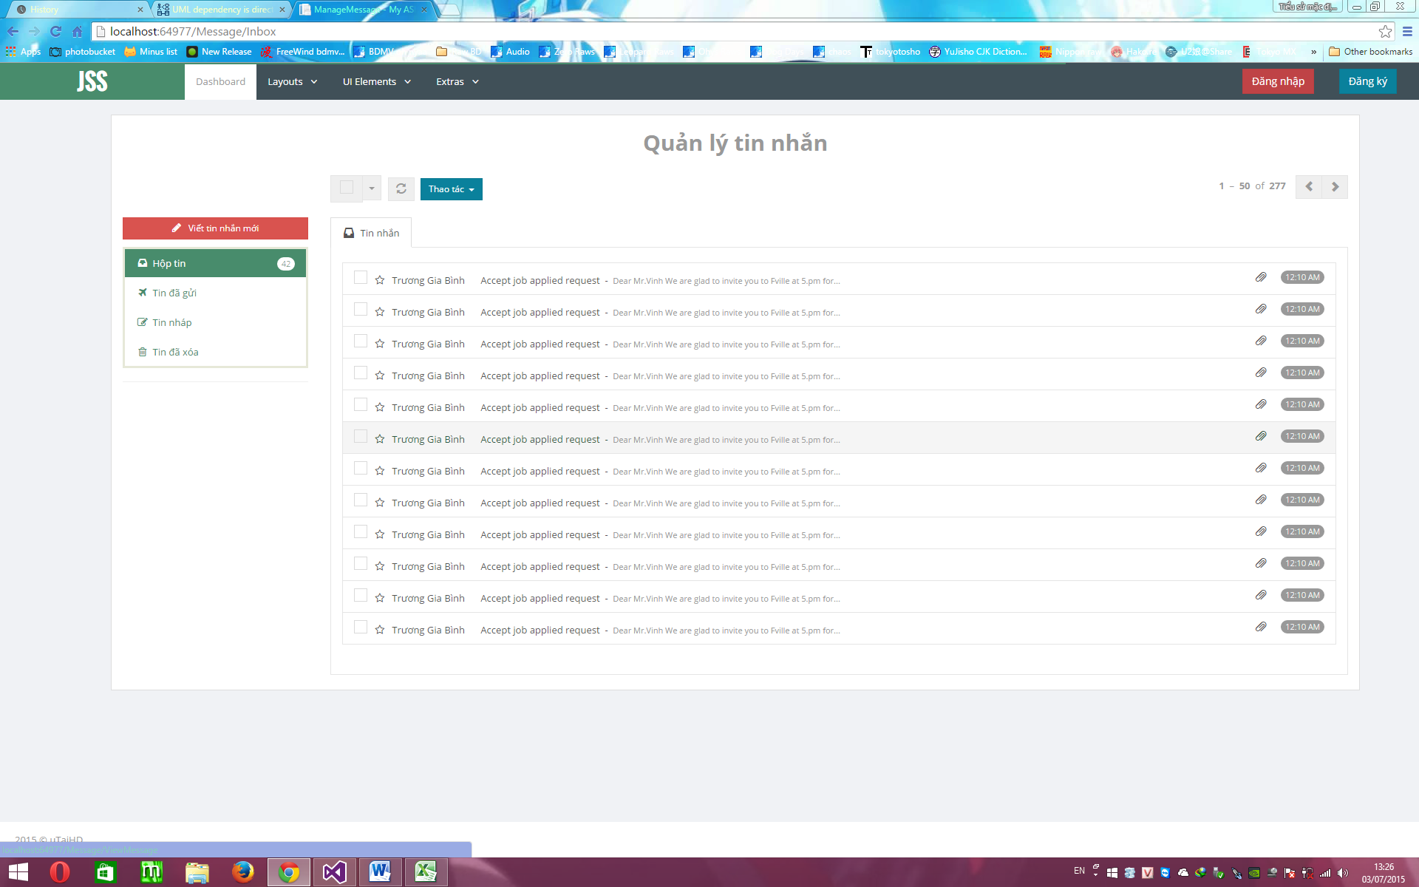

##### 4.6.6.1.2. Description

|  |  |  |  |  |  |  |
| --- | --- | --- | --- | --- | --- | --- |
| **No** | **Object Control Name** | **Object/ Control Name in English** | **Type** | **Required** | **Length** | **Description** |
| 1 | Viết tin nhắn mới | Write New Message | Button | N/A | N/A | Click on button to write a new message. |
| 2 | Hộp tin | Message Box |  | N/A | N/A | Show the number of message received. |
| 3 | Tin đã gửi | Message Sended | Filter | N/A | N/A | Click to show all sended message. |
| 4 | Tin nháp | Draft Message | Filter | N/A | N/A | Click to show all draft message. |
| 5 | Tin đã xóa | Deleted mesage | Filter | N/A | N/A | Click to show all deleted message. |
| 6 | Check box | Check Box | Label | N/A | N/A | Click to check/uncheck message for actions. |
| 7 | Sender’s name | Send’s Name | Text | N/A | N/A | Show sender’s name. Click to show message’s content. |
| 8 | Message’s title | Message’s Title | Text | N/A | N/A | Show message’s title. Click to show message’s content. |
| 9 | Message’s content | Message’s content | Text | N/A | N/A | Show the beginning part of message’s content. Click to show message’s content. |
| 10 | Tin nhắn | Message | Text | N/A | N/A | Show all message received with sender’s name, message’s title.. |
| 11 | Tất cả | All Filter | CheckBox | N/A | N/A | Click to show all message . |
| 12 | Đã đọc | Readed FIlter | CheckBox | N/A | N/A | Click to show all readed message. |
| 13 | Chưa đọc | Unread Filter | CheckBox | N/A | N/A | Click to show all unread message. |
| 14 | Đã đánh dấu | Marked Filter | CheckBox | N/A | N/A | Click to show all marked message. |
| 15 | Chưa đánh dấu | UnMarked Filter | CheckBox | N/A | N/A | Click to show all unmarked message. |
| 16 | Refresh | Refresh | Button | N/A | N/A | Click to refesh the page. |
| 17 | Thao tác | Action | DropDownList | N/A | N/A | Click to choose the action. |
| 18 | Đánh dấu đã xem tất cả tin nhắn | Mark all | Button on DropDownList | N/A | N/A | Click to mark all message. |
| 19 | Xóa các tin đã chọn | Delete Message | Button on DropDownList | N/A | N/A | Click to delete all marked message. |

#### 4.6.6.2. Detail

##### 4.6.6.2.1. Screen

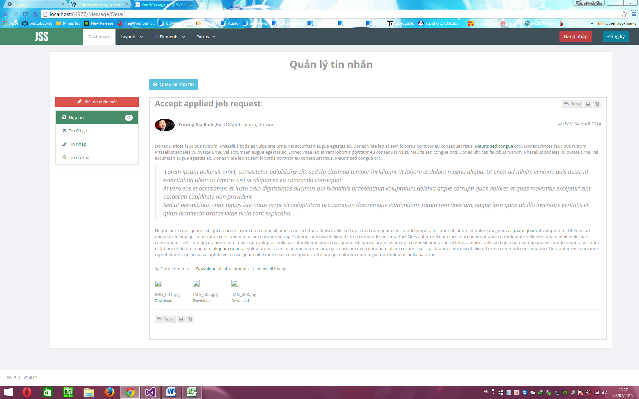

##### 4.6.6.2.2. Description

|  |  |  |  |  |  |  |
| --- | --- | --- | --- | --- | --- | --- |
| **No** | **Object Control Name** | **Object/ Control Name in English** | **Type** | **Required** | **Length** | **Description** |
| 1 | Quay lại hộp tin nhắn | Back To Message Box | Button | N/A | N/A | Click on button to go back to message box. |
| 2 | Message name | Message Name | Text | N/A | N/A | Show the message’s name. |
| 3 | Sender name | Sender Name | Text | N/A | N/A | Show the sender’s name. |
| 4 | Message content | Message’s content | Text | N/A | N/A | Show the message’s content. |
| 5 | Reply | Reply | Button | N/A | N/A | Click on button to open a window to write a reply. |
| 6 | In | Print | Button | N/A | N/A | Click on button to print this message. |
| 7 | Xóa | Delete | Button | N/A | N/A | Click on button to delete this message. |
| 8 | Download attachments | Download Attachments | Text | N/A | N/A | Click to download all attachment in this message. |
| 9 | View image | View Image | Text | N/A | N/A | Click to view all image on this message. |

### 4.6.7. ProfileController

#### 4.6.7.1. List

##### 4.6.7.1.1. Screen

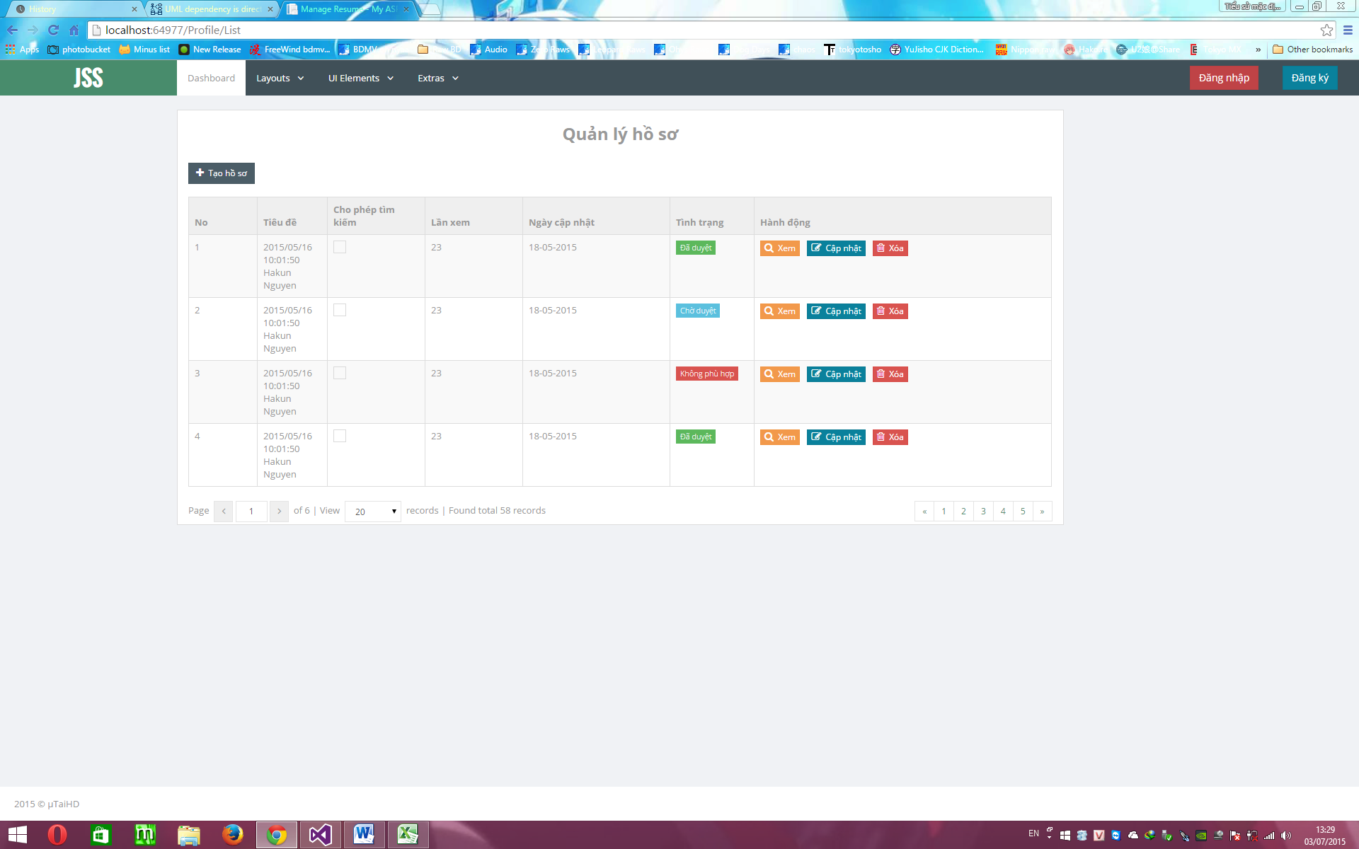

##### 4.6.7.1.2. Description

|  |  |  |  |  |  |  |
| --- | --- | --- | --- | --- | --- | --- |
| **No** | **Object Control Name** | **Object/ Control Name in English** | **Type** | **Required** | **Length** | **Description** |
| 1 | Tạo hồ sơ | Create Profile | Button | N/A | N/A | Click on button to open CreateProfile page to create a new profile. |
| 2 | No | No | Label | N/A | N/A | Show the number of profile. |
| 3 | Tiêu đề | Title | Label | N/A | N/A | Show the title of profile and the datetime created. |
| 4 | Cho phép tìm kiếm | Allow search | Check box | N/A | N/A | Click to allow/unAllow search by other people. |
| 5 | Lần xem | Views | Label | N/A | N/A | Show the number this profile viewed by other people. |
| 6 | Ngày cập nhật | Update DateTime | Label | N/A | N/A | Show the dateTime updated on this profile. |
| 7 | Tình trạng | Status | Label | N/A | N/A | Show the status of that profile. |
| 8 | Hành động | Action | Label | N/A | N/A | Show all action for that job. |
| 9 | Xem | View | Button | N/A | N/A | Click on button to view profile’s information in new tab. |
| 10 | Cập nhật | Update | Button | N/A | N/A | Click on button to open the update page in the new tab. |
| 11 | Xóa | Delete | Button | N/A | N/A | Click on button to delete this profile. |
| 12 | Page move forward | Page move forward | Button | N/A | N/A | Click on button to move to the next page. |
| 13 | Page move backward | Page move backward | Button | N/A | N/A | Click on button to move to the previous page. |
| 14 | View | View | DropdownList | N/A | N/A | Choose the number of request want to show on each page. |

#### 4.6.7.2. Create

##### 4.6.7.2.1. Screen

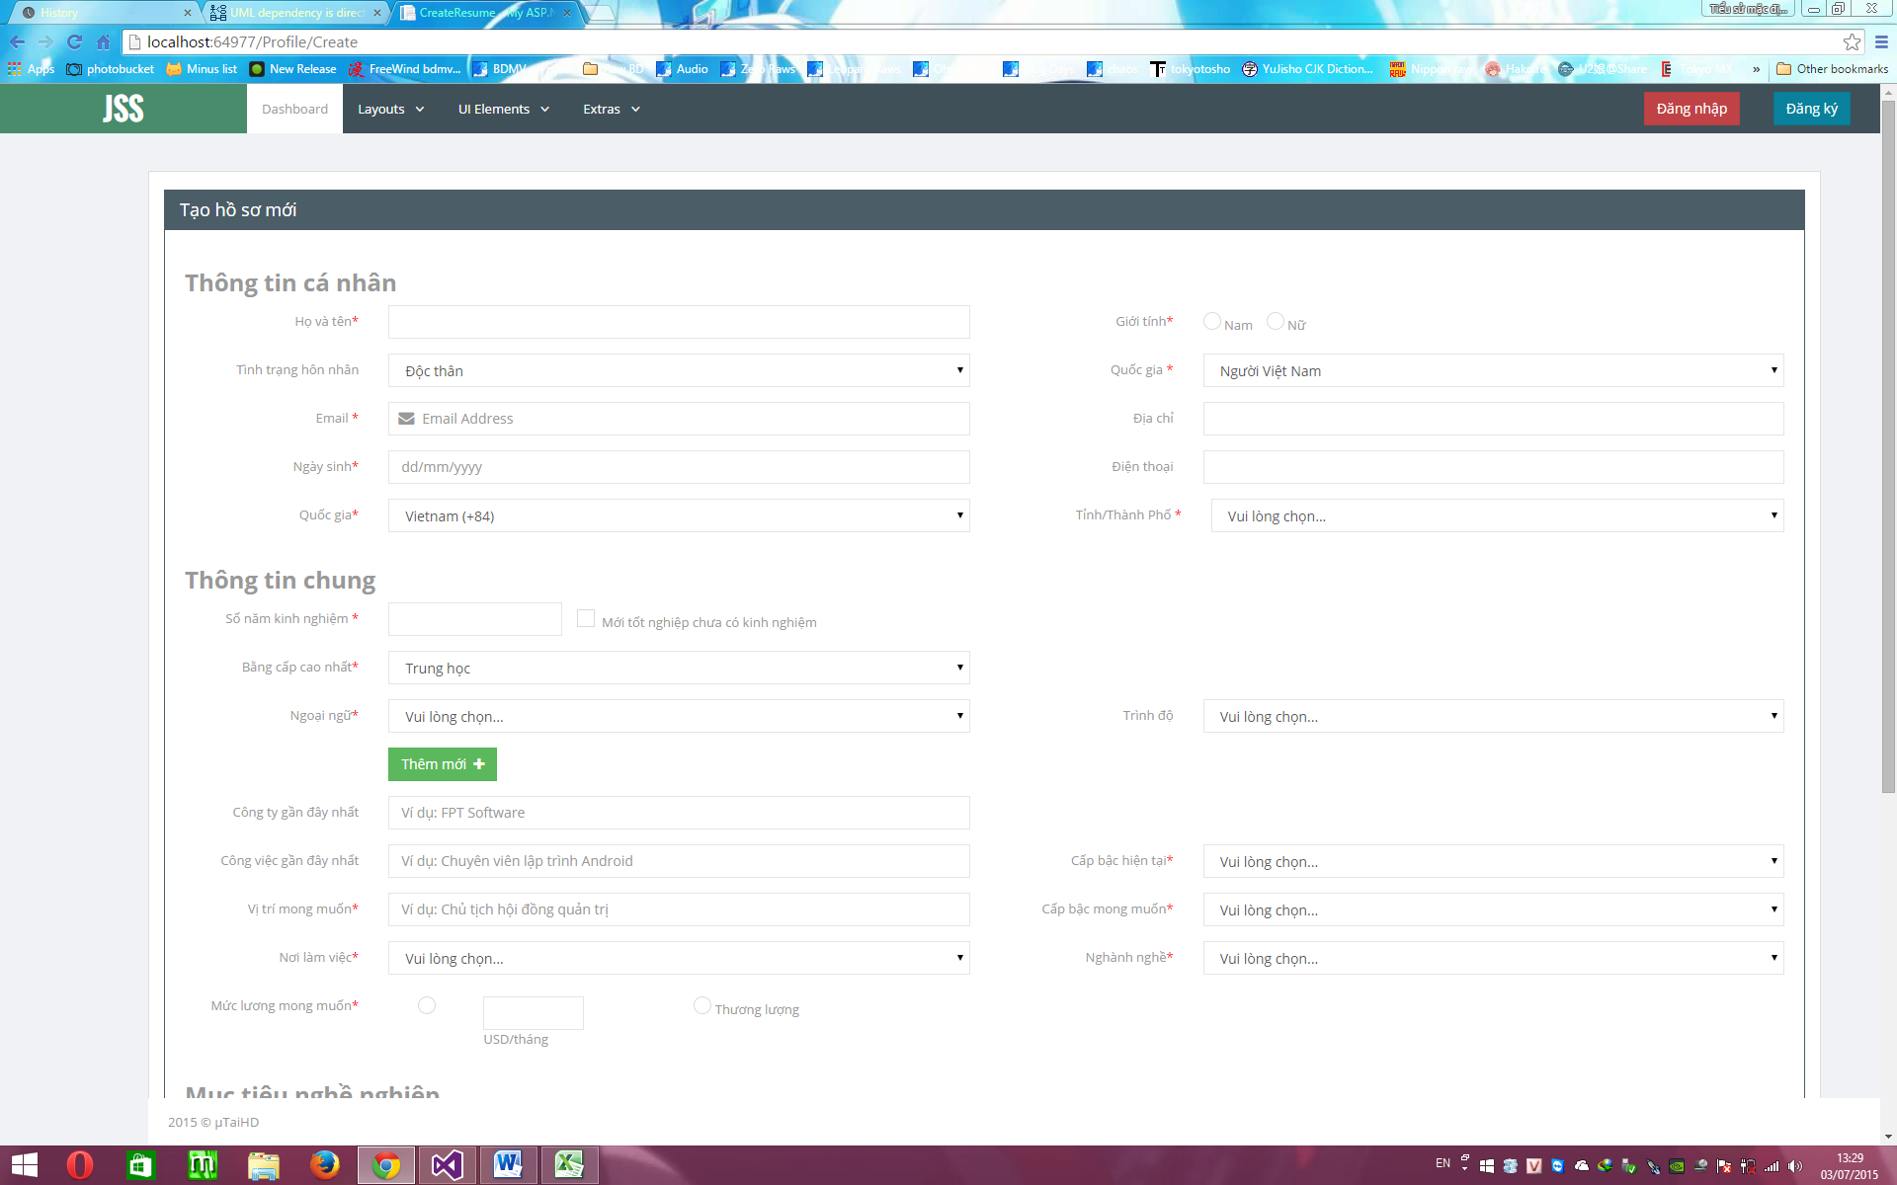

##### 4.6.7.2.2. Description

|  |  |  |  |  |  |  |
| --- | --- | --- | --- | --- | --- | --- |
| **No** | **Object Control Name** | **Object/ Control Name in English** | **Type** | **Required** | **Length** | **Description** |
| 1 | Họ và tên | Name | Text | Y | 50 | Input jobseeker’s name. |
| 2 | Giới tính | Gender |  | Y | N/A | Click to choose the jobseeker’s gender. |
| 3 | Tình trạng hôn nhân | Marial Staus | DropDownList | Y | N/A | Click to choose the marial status. |
| 4 | Quốc gia | Country | DropDownList | Y | N/A | Click to select the country. |
| 5 | Địa chỉ | Address | Text | N/A | 50 | Input the current address. |
| 6 | Email | Email | Text | Y | 50 | Input the Email. |
| 7 | Ngày sinh | BirthDay | DateTime | Y | N/A | Input the birth day. |
| 8 | Điện thoại | Phone | Text | N/A | 50 | Input the phone number. |
| 9 | Tỉnh/Thành Phố | City | DropDownList | Y | N/A | Click to choose the city. |
| 10 | Số năm kinh nghiệm | Year of experience | Text or CheckBox | Y | 10 | Input the year of experience or choose “Mới tốt nghiệp chưa có việc làm” check box. |
| 11 | Bằng cấp cao nhất | Highest Degree | DropDownList | Y | N/A | Click to choose the highest degree. |
| 12 | Ngoại ngữ | Language | DropDownList | Y | N/A | Click to choose the language. |
| 13 | Trình độ | Level Language | DropDownList | N/A | N/A | Click to choose the level of language. |
| 14 | Công ty gần đây nhất | Last Company | Text | N/A | 50 | Input the last company working for. |
| 15 | Công việc gần đây nhất | Last Job | Text | N/A | 50 | Input the last job working. |
| 16 | Cấp bậc hiện tại | Curent Position | DropDownList | Y | N/A | Click to choose the current position. |
| 17 | Vị trí mong muốn | Desired Position | DropDownList | Y | N/A | Click to choose the desired position. |
| 18 | Cấp bậc mong muốn | Desired Level | DropDownList | Y | N/A | Click to choose the level desired position. |
| 19 | Nơi làm việc | Location | DropDownList | Y | N/A | Click to choose the work location. |
| 20 | Ngành nghề | Job Category | DropDownList | Y | N/A | Click to choose the job category. |
| 21 | Mức lương mong muốn | Desired Salary | Text or check box | Y | 50 | Click to choose the desired salary or choose “Thương lượng” check box |
| 22 | Tạo mới | Create | Button | N/A | N/A | Click on button to create a new profile. |

### 4.6.8. TopicController

#### 4.6.8.1. List

##### 4.6.8.1.1. Screen

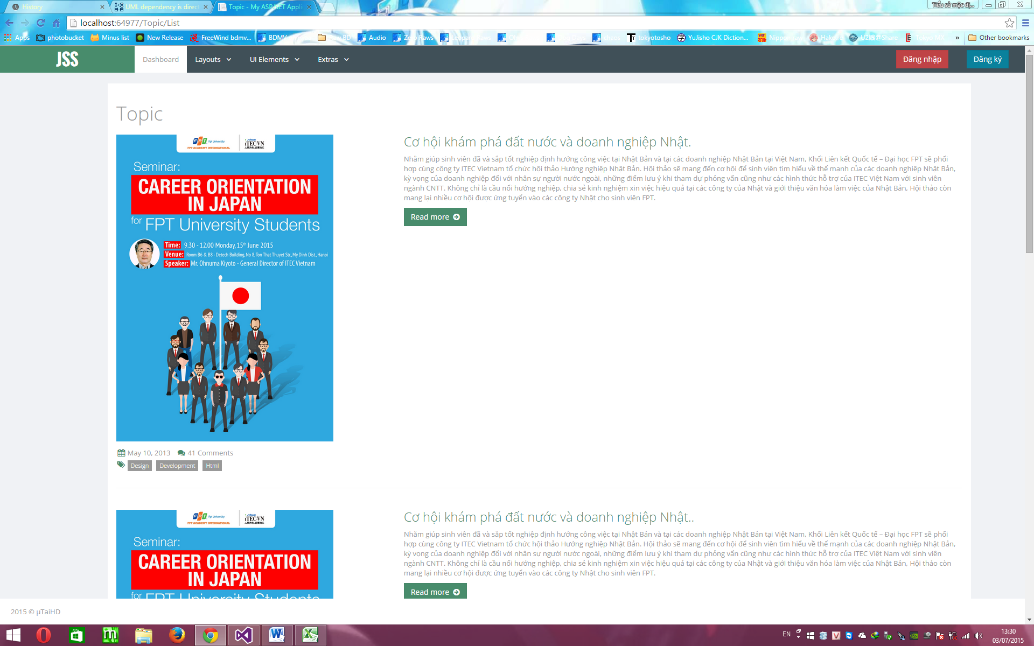

##### 4.6.8.1.2. Description

|  |  |  |  |  |  |  |
| --- | --- | --- | --- | --- | --- | --- |
| **No** | **Object Control Name** | **Object/ Control Name in English** | **Type** | **Required** | **Length** | **Description** |
| 1 | Topic title | Topic title | Text | N/A | N/A | Show the title of the topic. |
| 2 | Read more | Read More | Button | N/A | N/A | Click on button to show the topic’s content. |
| 3 | Topic image | Topic image | image | N/A | N/A | Show the image of topic. |
| 4 | Views | Views | Text | N/A | N/A | Show the number of viewed on that topic. |

#### 4.6.8.2. Create

##### 4.6.8.2.1. Screen

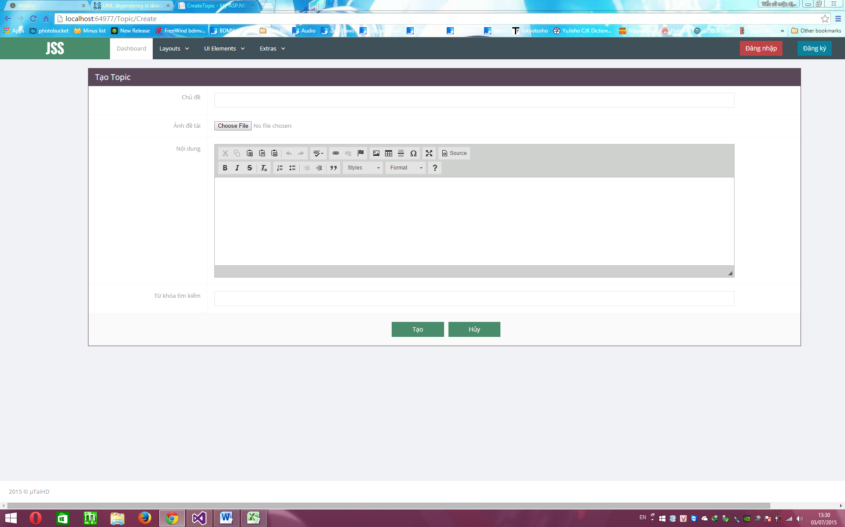

##### 4.6.8.2.2. Description

|  |  |  |  |  |  |  |
| --- | --- | --- | --- | --- | --- | --- |
| **No** | **Object Control Name** | **Object/ Control Name in English** | **Type** | **Required** | **Length** | **Description** |
| 1 | Chủ đề | Topic Title | Text | Y | 500 | Input the topic’s title. |
| 2 | Ảnh đề tài | Topic Picture | Button | Y | N/A | Click on button to upload the topic image. |
| 3 | Nội dung | Topic Content | Text | Y | 5000 | Input the topic content. |
| 4 | Từ khóa tìm kiếm | Search key | Text | Y | 50 | Input the search key for this topic. |
| 5 | Tạo | Create | Button | N/A | N/A | Click on button to create new topic. |
| 6 | Hủy | Cancel | Button | N/A | N/A | Click on button to cancel action. |

#### 4.6.8.3. Detail

##### 4.6.8.3.1. Screen

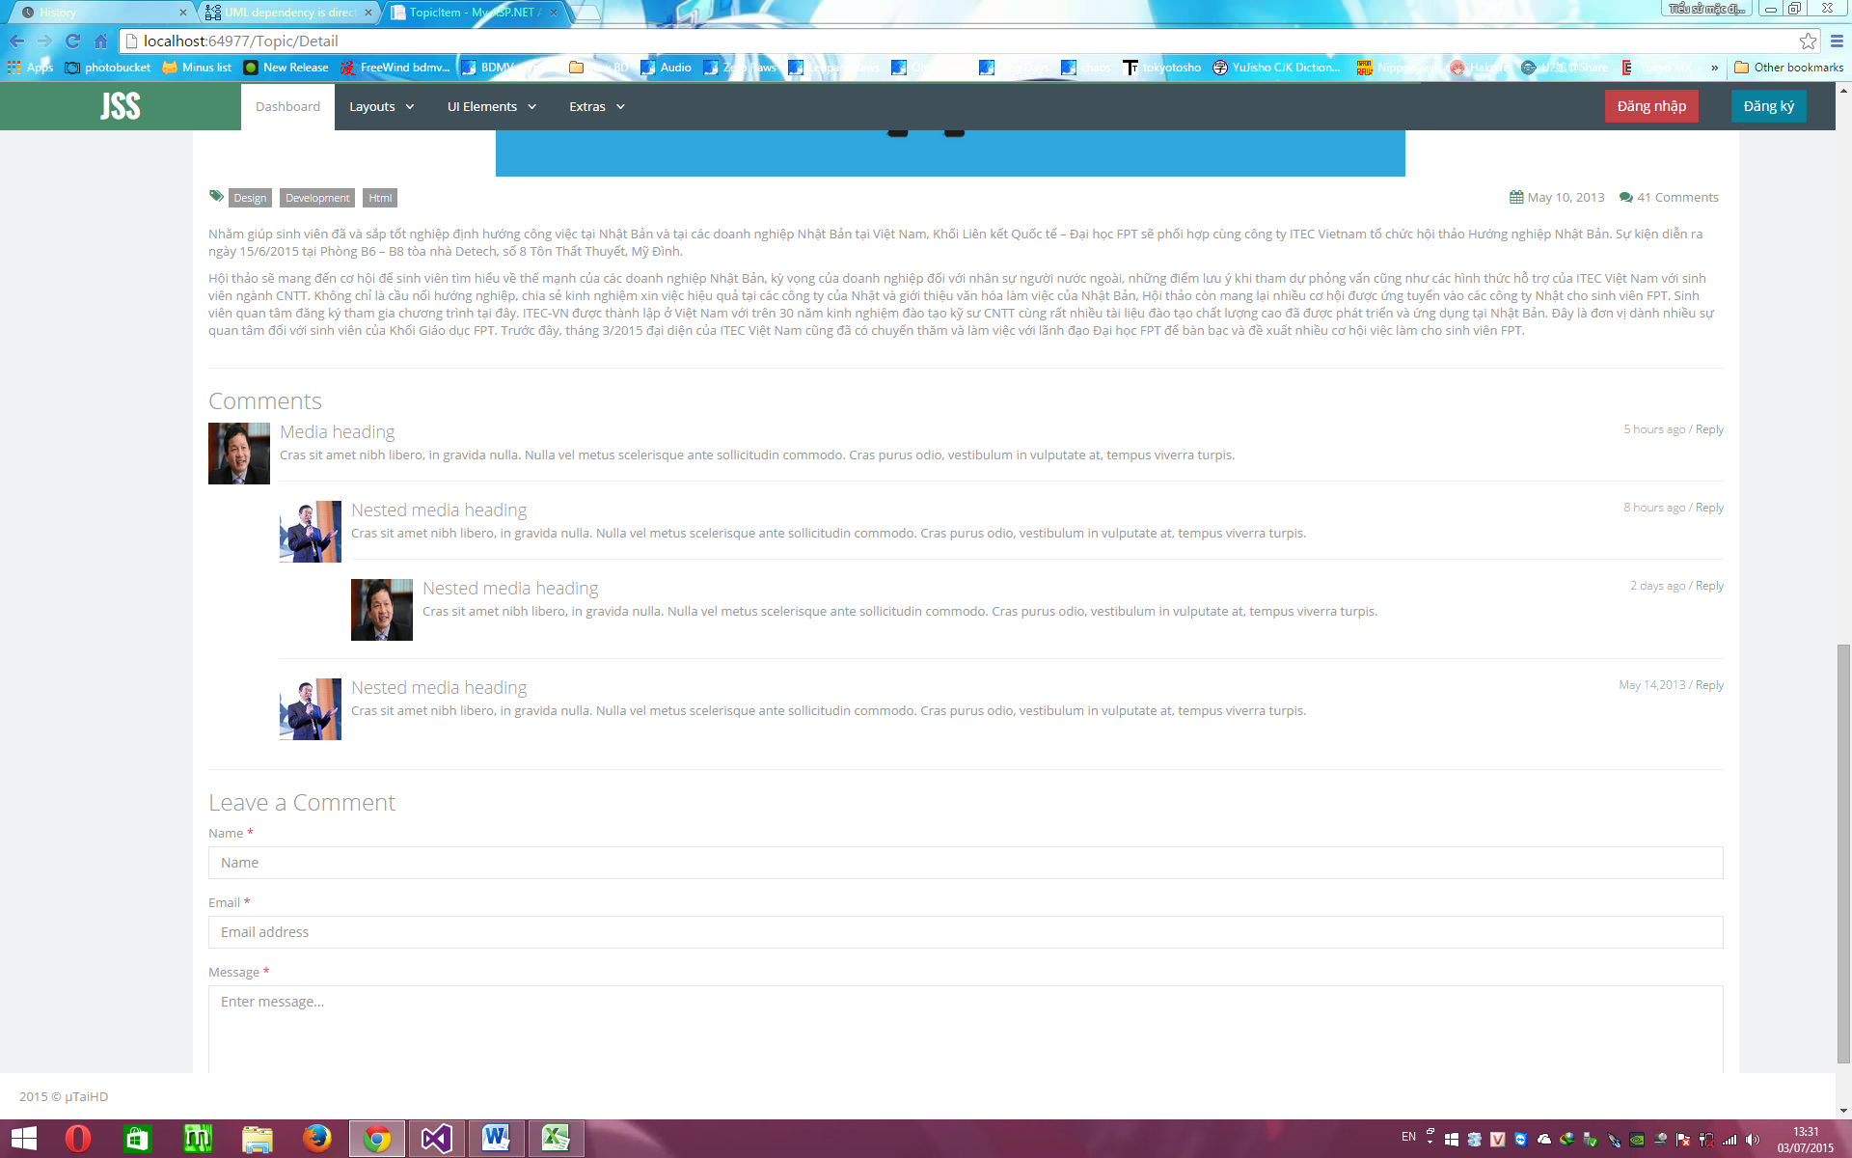

##### 4.6.8.3.2. Description

|  |  |  |  |  |  |  |
| --- | --- | --- | --- | --- | --- | --- |
| **No** | **Object Control Name** | **Object/ Control Name in English** | **Type** | **Required** | **Length** | **Description** |
| 1 | Nội dung | Topic Content | Text | N/A | N/A | Show the topic’s content. |
| 2 | Comment | Comment | Text | N/A | N/A | Show the comment for this topic. |
| 3 | Name | Name | Text | Y | 50 | Input the name of reviewer. |
| 4 | Email | Email | Text | Y | 50 | Input the email of reviewer. |
| 5 | Message | Content | Text | Y | 500 | Input the content of comment. |
| 6 | Post Comment | Post Comment | Button | N/A | N/A | Click on button to post thí comment. |

## 4.7. Database Design

### 4.7.1. Database Diagram

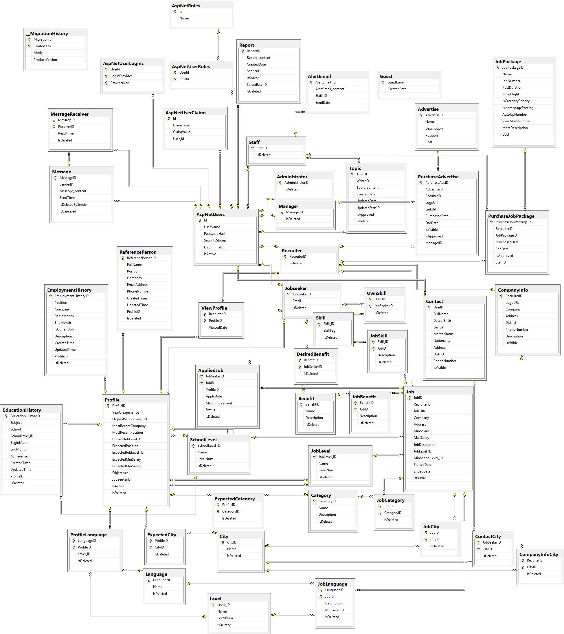

Figure 4. 26 – Database Diagram

### 4.7.2. Database Description

#### 4.7.2.1. Table Administrator

|  |  |  |  |  |
| --- | --- | --- | --- | --- |
| No. | Attribute | Type | Constraints | Description |
| 1 | AdministratorID | nvarchar(128) | PRIMARY KEY, FOREIGN KEY, NOT NULL | Id of administrator account |
| 2 | IsDeleted | bit | NOT NULL | Logical delete flag |

Table 4. 1 – Administrator

#### 4.7.2.2. Table Advertise

|  |  |  |  |  |
| --- | --- | --- | --- | --- |
| No. | Attribute | Type | Constraints | Description |
| 1 | AdvertiseID | int | PRIMARY KEY, NOT NULL | Id of advertise |
| 2 | Name | nvarchar(50) | NOT NULL | Name of advertise |
| 3 | Description | nvarchar(200) | NOT NULL | Description of advertise |
| 4 | Position | nvarchar(50) | NOT NULL | Position in website |
| 5 | Cost | money | NOT NULL | Cost of advertise |
| 6 | IsDeleted | bit | NOT NULL | Logical delete flag |

Table 4. 2 – Advertise

#### 4.7.2.3. Table AppliedJob

|  |  |  |  |  |
| --- | --- | --- | --- | --- |
| No. | Attribute | Type | Constraints | Description |
| 1 | JobSeekerID | nvarchar(128) | PRIMARY KEY, FOREIGN KEY, NOT NULL | Id of jobseeker |
| 2 | JobID | int | PRIMARY KEY, FOREIGN KEY, NOT NULL | Id of job |
| 3 | ProfileID | int | NOT NULL | Id of profile |
| 4 | ApplyDate | date | NOT NULL | Applied date |
| 5 | MatchingPercent | int | NOT NULL | Matching percent between profile and job requirement |
| 6 | Status | int | NOT NULL | Application’s status |
| 7 | IsDeleted | bit | NOT NULL | Logical delete flag |

Table 4. 3 – AppliedJob

#### 4.7.2.4. Table AspNetRoles

|  |  |  |  |  |
| --- | --- | --- | --- | --- |
| No. | Attribute | Type | Constraints | Description |
| 1 | Id | nvarchar(128) | PRIMARY KEY, NOT NULL | Id of role |
| 2 | Name | nvarchar(MAX) | NOT NULL | Name of role |

Table 4. 4 – AspNetRoles

#### 4.7.2.5. Table AspNetUserClaims

|  |  |  |  |  |
| --- | --- | --- | --- | --- |
| No. | Attribute | Type | Constraints | Description |
| 1 | Id | int | PRIMARY KEY, NOT NULL | Id of User Claim |
| 2 | ClaimType | nvarchar(MAX) |  | Type of User Claim |
| 3 | ClaimValue | nvarchar(MAX) |  | Value of User Claim |
| 4 | User_Id | nvarchar(128) | FOREIGN KEY, NOT NULL | Id of account |

Table 4. 5 – AspNetUserClaims

#### 4.7.2.6. Table AspNetUserLogins

|  |  |  |  |  |
| --- | --- | --- | --- | --- |
| No. | Attribute | Type | Constraints | Description |
| 1 | UserId | nvarchar(128) | PRIMARY KEY, FOREIGN KEY, NOT NULL | Id of account |
| 2 | LoginProvider | nvarchar(128) | NOT NULL | Provider |
| 3 | ProviderKey | nvarchar(128) | NOT NULL | Key of provider |

Table 4. 6 – AspNetUserLogins

#### 4.7.2.7. Table AspNetUserRoles

|  |  |  |  |  |
| --- | --- | --- | --- | --- |
| No. | Attribute | Type | Constraints | Description |
| 1 | UserId | nvarchar(128) | PRIMARY KEY, FOREIGN KEY, NOT NULL | Id of account |
| 2 | RoleId | nvarchar(128) | PRIMARY KEY, FOREIGN KEY, NOT NULL | Id of role |

Table 4. 7 – AspNetUserRoles

#### 4.7.2.8. Table AspNetUsers

|  |  |  |  |  |
| --- | --- | --- | --- | --- |
| No. | Attribute | Type | Constraints | Description |
| 1 | Id | nvarchar(128) | PRIMARY KEY, NOT NULL | Id of account |
| 2 | UserName | nvarchar(MAX) |  | Username |
| 3 | PasswordHash | nvarchar(MAX) |  | Password |
| 4 | SecurityStamp | nvarchar(MAX) |  | Security Stamp |
| 5 | Discriminator | nvarchar(128) | NOT NULL | Discriminator |
| 6 | IsActive | bit | NOT NULL | Is active or de-active |

Table 4. 8 – AspNetUsers

#### 4.7.2.9. Table Benefit

|  |  |  |  |  |
| --- | --- | --- | --- | --- |
| No. | Attribute | Type | Constraints | Description |
| 1 | BenefitID | int | PRIMARY KEY, NOT NULL | Id of benefit |
| 2 | Name | nvarchar(50) | NOT NULL | Name of benefit |
| 3 | Description | nvarchar(100) |  | Description of benefit |
| 4 | IsDeleted | bit | NOT NULL | Logical delete flag |

Table 4. 9 – Benefit

#### 4.7.2.10. Table Category

|  |  |  |  |  |
| --- | --- | --- | --- | --- |
| No. | Attribute | Type | Constraints | Description |
| 1 | CategoryID | int | PRIMARY KEY, NOT NULL | Id of category |
| 2 | Name | nvarchar(50) | NOT NULL | Name of category |
| 3 | Description | nvarchar(100) |  | Description of category |
| 4 | IsDeleted | bit | NOT NULL | Logical delete flag |

Table 4. 10 – Category

#### 4.7.2.11. Table City

|  |  |  |  |  |
| --- | --- | --- | --- | --- |
| No. | Attribute | Type | Constraints | Description |
| 1 | CityID | int | PRIMARY KEY, NOT NULL | Id of city |
| 2 | Name | nvarchar(50) | NOT NULL | Name of city |
| 3 | IsDeleted | bit | NOT NULL | Logical delete flag |

Table 4. 11 – City

#### 4.7.2.12. Table CompanyInfo

|  |  |  |  |  |
| --- | --- | --- | --- | --- |
| No. | Attribute | Type | Constraints | Description |
| 1 | RecruiterID | nvarchar(128) | PRIMARY KEY, NOT NULL | Id of recruiter |
| 2 | LogoURL | nvarchar(150) |  | Logo’s link |
| 3 | Company | nvarchar(100) | NOT NULL | Company’s name |
| 4 | Address | nvarchar(100) |  | Address of company |
| 5 | District | nvarchar(30) |  | Located district |
| 6 | PhoneNumber | nvarchar(20) |  | Phone number of company |
| 7 | Description | ntext |  | Description of company |
| 8 | IsVisible | bit | NOT NULL | Can other view it or not |

Table 4. 12 – CompanyInfo

#### 4.7.2.13. Table CompanyInfoCity

|  |  |  |  |  |
| --- | --- | --- | --- | --- |
| No. | Attribute | Type | Constraints | Description |
| 1 | RecuiterID | nvarchar(128) | PRIMARY KEY, FOREIGN KEY, NOT NULL | Id of recruiter |
| 2 | CityID | int | NOT NULL | Id of city |
| 3 | IsDeleted | bit | NOT NULL | Logical delete flag |

Table 4. 13 – CompanyInfoCity

#### 4.7.2.14. Table Contact

|  |  |  |  |  |
| --- | --- | --- | --- | --- |
| No. | Attribute | Type | Constraints | Description |
| 1 | UserID | nvarchar(128) | PRIMARY KEY, FOREIGN KEY, NOT NULL | Id of account |
| 2 | FullName | nvarchar(150) | NOT NULL | Full-name of jobseeker |
| 3 | Gender | bit | NOT NULL | Gender of jobseeker |
| 4 | MaritalStatus | bit | NOT NULL | Marital status of jobseeker |
| 5 | Nationality | bit | NOT NULL | Nationality of jobseeker |
| 6 | Address | nvarchar(150) |  | Address of jobseeker |
| 7 | DateofBirth | date | NOT NULL | Birthday of jobseeker |
| 8 | PhoneNumber | nvarchar(20) | NOT NULL | Phone number of jobseeker |
| 9 | AvatarUrl | nvarchar(250) |  | Avatar’s link |
| 10 | CityID | int | NOT NULL | Id of city |
| 11 | District | nvarchar(20) |  | Located district |
| 12 | IsVisible | bit | NOT NULL | Can recruiter read or not |

Table 4. 14 – Contact

#### 4.7.2.15. Table DesiredBenefit

|  |  |  |  |  |
| --- | --- | --- | --- | --- |
| No. | Attribute | Type | Constraints | Description |
| 1 | BenefitID | int | PRIMARY KEY, FOREIGN KEY, NOT NULL | Id of benefit |
| 2 | JobSeekerID | nvarchar(128) | PRIMARY KEY, FOREIGN KEY, NOT NULL | Id of jobseeker |
| 3 | IsDeleted | bit | NOT NULL | Logical delete flag |

Table 4. 15 – DesiredBenefit

#### 4.7.2.16. Table EducationHistory

|  |  |  |  |  |
| --- | --- | --- | --- | --- |
| No. | Attribute | Type | Constraints | Description |
| 1 | EducationHistoryID | int | PRIMARY KEY, NOT NULL | Id of education history |
| 2 | Subject | nvarchar(50) | NOT NULL | Subject |
| 3 | School | nvarchar(50) | NOT NULL | School name |
| 4 | SchoolLevel_ID | int | NOT NULL | Id of School Level |
| 5 | Achievement | ntext |  | Achievement description |
| 6 | ProfileID | int | FOREIGN KEY, NOT NULL | Id of profile |
| 7 | IsDeleted | bit | NOT NULL | Logical delete flag |

Table 4. 16 – EducationHistory

#### 4.7.2.17. Table EmploymentHistory

|  |  |  |  |  |
| --- | --- | --- | --- | --- |
| No. | Attribute | Type | Constraints | Description |
| 1 | EmploymentHistoryID | int | PRIMARY KEY, NOT NULL | Id of employment history |
| 2 | Position | nvarchar(50) | NOT NULL | Job’s position |
| 3 | Company | nvarchar(50) | NOT NULL | Company name |
| 4 | WorkingTime | int | NOT NULL | Working time |
| 5 | Description | ntext |  | Description |
| 6 | ProfileID | int | FOREIGN KEY, NOT NULL | Id of profile |
| 7 | IsDeleted | bit | NOT NULL | Logical delete flag |

Table 4. 17 – EmploymentHistory

#### 4.7.2.18. Table ExpectedCategory

|  |  |  |  |  |
| --- | --- | --- | --- | --- |
| No. | Attribute | Type | Constraints | Description |
| 1 | ProfileID | int | PRIMARY KEY, FOREIGN KEY, NOT NULL | Id of profile |
| 2 | CategoryID | int | PRIMARY KEY, FOREIGN KEY, NOT NULL | Id of category |
| 3 | IsDeleted | bit | NOT NULL | Logical delete flag |

Table 4. 18 – ExpectedCategory

#### 4.7.2.19. Table ExpectedCity

|  |  |  |  |  |
| --- | --- | --- | --- | --- |
| No. | Attribute | Type | Constraints | Description |
| 1 | ProfileID | int | PRIMARY KEY, FOREIGN KEY, NOT NULL | Id of profile |
| 2 | CityID | int | PRIMARY KEY, FOREIGN KEY, NOT NULL | Id of city |
| 3 | IsDeleted | bit | NOT NULL | Logical delete flag |

Table 4. 19 – ExpectedCity

#### 4.7.2.20. Table Job

|  |  |  |  |  |
| --- | --- | --- | --- | --- |
| No. | Attribute | Type | Constraints | Description |
| 1 | JobID | int | PRIMARY KEY, NOT NULL | Id of job |
| 2 | RecruiterID | nvarchar(128) | FOREIGN KEY, NOT NULL | Id of recruiter |
| 3 | JobTitle | nvarchar(50) | NOT NULL | Title of job |
| 4 | Company | nvarchar(50) | NOT NULL | Company name |
| 5 | Address | nvarchar(100) | NOT NULL | Address |
| 6 | MinSalary | money |  | Min salary |
| 7 | MaxSalary | money |  | Max salary |
| 8 | JobDescription | ntext | NOT NULL | Description of job |
| 9 | JobRequirement | ntext |  | Requirement of job |
| 10 | JobLevel_ID | int | FOREIGN KEY, NOT NULL | Id of job level |
| 11 | MinSchoolLevel_ID | int | FOREIGN KEY, NOT NULL | Id of min school level |
| 12 | JobView | bigint | NOT NULL | View count of job |
| 13 | StartedDate | date |  | Date of creating |
| 14 | EndedDate | date |  | Date of ending |
| 15 | IsPublic | bit | NOT NULL | Logical delete flag |

Table 4. 20 – Job

#### 4.7.2.21. Table JobBenefit

|  |  |  |  |  |
| --- | --- | --- | --- | --- |
| No. | Attribute | Type | Constraints | Description |
| 1 | BenefitID | int | PRIMARY KEY, FOREIGN KEY, NOT NULL | Id of benefit |
| 2 | JobID | int | PRIMARY KEY, FOREIGN KEY, NOT NULL | Id of job |
| 3 | Description | nvarchar(100) |  | Description |
| 4 | IsDeleted | bit | NOT NULL | Logical delete flag |

Table 4. 21 – JobBenefit

#### 4.7.2.22. Table JobCategory

|  |  |  |  |  |
| --- | --- | --- | --- | --- |
| No. | Attribute | Type | Constraints | Description |
| 1 | CategoryID | int | PRIMARY KEY, FOREIGN KEY, NOT NULL | Id of category |
| 2 | JobID | int | PRIMARY KEY, FOREIGN KEY, NOT NULL | Id of job |
| 3 | IsDeleted | bit | NOT NULL | Logical delete flag |

Table 4. 22 – JobCategory

#### 4.7.2.23. Table JobCity

|  |  |  |  |  |
| --- | --- | --- | --- | --- |
| No. | Attribute | Type | Constraints | Description |
| 1 | JobID | int | PRIMARY KEY, FOREIGN KEY, NOT NULL | Id of job |
| 2 | CityID | int | PRIMARY KEY, FOREIGN KEY, NOT NULL | Id of city |
| 3 | IsDeleted | bit | NOT NULL | Logical delete flag |

Table 4. 23 – JobCity

#### 4.7.2.24. Table JobLanguage

|  |  |  |  |  |
| --- | --- | --- | --- | --- |
| No. | Attribute | Type | Constraints | Description |
| 1 | LanguageID | int | PRIMARY KEY, FOREIGN KEY, NOT NULL | Id of language |
| 2 | JobID | int | PRIMARY KEY, FOREIGN KEY, NOT NULL | Id of job |
| 3 | Description | ntext |  | Description |
| 4 | MinLevel_ID | int | FOREIGN KEY, NOT NULL | Id of min level |
| 5 | IsDeleted | bit | NOT NULL | Logical delete flag |

Table 4. 24 – JobLanguage

#### 4.7.2.25. Table JobLevel

|  |  |  |  |  |
| --- | --- | --- | --- | --- |
| No. | Attribute | Type | Constraints | Description |
| 1 | JobLevel_ID | int | PRIMARY KEY, NOT NULL | Id of job level |
| 2 | Name | nvarchar(50) | NOT NULL | Name |
| 3 | LevelNum | int | NOT NULL | Number to comparison |
| 4 | IsDeleted | bit | NOT NULL | Logical delete flag |

Table 4. 25 – JobLevel

#### 4.7.2.26. Table JobPackage

|  |  |  |  |  |
| --- | --- | --- | --- | --- |
| No. | Attribute | Type | Constraints | Description |
| 1 | JobPackageID | int | PRIMARY KEY, NOT NULL | Id of job package |
| 2 | Name | nvarchar(50) | NOT NULL | Name |
| 3 | JobNumber | int | NOT NULL | Number of job that recruiter can create |
| 4 | PostDuration | int | NOT NULL | Duration of job |
| 5 | IsHighlight | bit | NOT NULL | Can Highlight or not |
| 6 | IsCategoryPriority | bit | NOT NULL | Can get high priority when searched or not |
| 7 | IsHomepagePosting | bit | NOT NULL | Can be showed on homepage or not |
| 8 | ViewMultiNumber | int | NOT NULL | The higher the value is, the more view count increase |
| 9 | MoreDescription | nvarchar(50) | NOT NULL | More Description |
| 10 | Cost | money | NOT NULL | Cost |
| 11 | IsDeleted | bit | NOT NULL | Logical delete flag |

Table 4. 26 – JobPackage

#### 4.7.2.27. Table Jobseeker

|  |  |  |  |  |
| --- | --- | --- | --- | --- |
| No. | Attribute | Type | Constraints | Description |
| 1 | JobSeekerID | nvarchar(128) | PRIMARY KEY, FOREIGN KEY, NOT NULL | Id of jobseeker |
| 2 | FullName | nvarchar(150) | NOT NULL | Full-name |
| 3 | Email | nvarchar(150) | NOT NULL | Email |
| 4 | PhoneNumber | nvarchar(20) | NOT NULL | Phone number |
| 5 | IsDeleted | bit | NOT NULL | Logical delete flag |

Table 4. 27 – Jobseeker

#### 4.7.2.28. Table JobSkill

|  |  |  |  |  |
| --- | --- | --- | --- | --- |
| No. | Attribute | Type | Constraints | Description |
| 1 | Skill_ID | int | PRIMARY KEY, FOREIGN KEY, NOT NULL | Id of skill |
| 2 | JobID | int | PRIMARY KEY, FOREIGN KEY, NOT NULL | Id of job |
| 3 | Description | nvarchar(100) |  | Description |
| 4 | IsDeleted | bit | NOT NULL | Logical delete flag |

Table 4. 28 – JobSkill

#### 4.7.2.29. Table Language

|  |  |  |  |  |
| --- | --- | --- | --- | --- |
| No. | Attribute | Type | Constraints | Description |
| 1 | LanguageID | int | PRIMARY KEY, NOT NULL | Id of language |
| 2 | Name | nvarchar(50) | NOT NULL | Name |
| 3 | IsDeleted | bit | NOT NULL | Logical delete flag |

Table 4. 29 – Language

#### 4.7.2.30. Table Level

|  |  |  |  |  |
| --- | --- | --- | --- | --- |
| No. | Attribute | Type | Constraints | Description |
| 1 | Level_ID | int | PRIMARY KEY, NOT NULL | Id of level |
| 2 | Name | nvarchar(50) | NOT NULL | Name |
| 3 | LevelNum | int | NOT NULL | Number for comparison |
| 4 | IsDeleted | bit | NOT NULL | Logical delete flag |

Table 4. 30 – Level

#### 4.7.2.31. Table Manager

|  |  |  |  |  |
| --- | --- | --- | --- | --- |
| No. | Attribute | Type | Constraints | Description |
| 1 | ManagerID | nvarchar(128) | PRIMARY KEY, FOREIGN KEY, NOT NULL | Id of manager |
| 2 | IsDeleted | bit | NOT NULL | Logical delete flag |

Table 4. 31 – Manager

#### 4.7.2.32. Table Message

|  |  |  |  |  |
| --- | --- | --- | --- | --- |
| No. | Attribute | Type | Constraints | Description |
| 1 | MessageID | int | PRIMARY KEY, NOT NULL | Id of message |
| 2 | SenderID | nvarchar(128) | FOREIGN KEY, NOT NULL | Id of sender |
| 3 | Message_content | ntext | NOT NULL | Content of message |
| 4 | SendTime | datetime | NOT NULL | Sent time |
| 5 | IsDeletedBySender | bit | NOT NULL | Can Sender see that message or not |
| 6 | IsCanceled | bit | NOT NULL | Can both Sender and Receiver see that message or not |

Table 4. 32 – Message

#### 4.7.2.33. Table MessageReceiver

|  |  |  |  |  |
| --- | --- | --- | --- | --- |
| No. | Attribute | Type | Constraints | Description |
| 1 | MessageID | int | PRIMARY KEY, FOREIGN KEY, NOT NULL | Id of message |
| 2 | ReceiverID | nvarchar(128) | PRIMARY KEY, FOREIGN KEY, NOT NULL | Id of receiver |
| 3 | ReadTime | datetime |  | Read time |
| 4 | IsDeleted | bit | NOT NULL | Logical delete flag |

Table 4. 33 – MessageReceiver

#### 4.7.2.34. Table OwnSkill

|  |  |  |  |  |
| --- | --- | --- | --- | --- |
| No. | Attribute | Type | Constraints | Description |
| 1 | Skill_ID | int | PRIMARY KEY, FOREIGN KEY, NOT NULL | Id of skill |
| 2 | JobSeekerID | nvarchar(128) | PRIMARY KEY, FOREIGN KEY, NOT NULL | Id of jobseeker |
| 3 | IsDeleted | bit | NOT NULL | Logical delete flag |

Table 4. 34 – OwnSkill

#### 4.7.2.35. Table Profile

|  |  |  |  |  |
| --- | --- | --- | --- | --- |
| No. | Attribute | Type | Constraints | Description |
| 1 | ProfileID | int | PRIMARY KEY, NOT NULL | Id of profile |
| 2 | Name | nvarchar(50) | NOT NULL | Name |
| 3 | YearOfExperience | int | NOT NULL | Year of experience |
| 4 | HighestSchoolLevel_ID | int | FOREIGN KEY, NOT NULL | Id of highest school level |
| 5 | LanguageID | int | FOREIGN KEY | Id of language |
| 6 | Level_ID | int | FOREIGN KEY | Id of level |
| 7 | MostRecentCompany | nvarchar(50) |  | Most recent company name |
| 8 | MostRecentPosition | nvarchar(50) |  | Most recent job position |
| 9 | CurrentJobLevel_ID | int | FOREIGN KEY | Id of current job level |
| 10 | ExpectedPosition | nvarchar(50) | NOT NULL | Expected job position |
| 11 | ExpectedJobLevel_ID | int | FOREIGN KEY, NOT NULL | Id of expected job level |
| 12 | ExpectedSalary | money | NOT NULL | Expected salary |
| 13 | CreatedTime | datetime | NOT NULL | Created time |
| 14 | UpdatedTime | datetime | NOT NULL | Updated time |
| 15 | Objectives | ntext | NOT NULL | Objectives |
| 16 | PercentStatus | int | NOT NULL | Percent of created profile |
| 17 | JobSeekerID | nvarchar(128) | FOREIGN KEY, NOT NULL | Id of jobseeker |
| 18 | IsActive | bit | NOT NULL | Is active or not |
| 19 | IsDeleted | bit | NOT NULL | Logical delete flag |

Table 4. 35 – Profile

#### 4.7.2.36. Table PurchaseAdvertise

|  |  |  |  |  |
| --- | --- | --- | --- | --- |
| No. | Attribute | Type | Constraints | Description |
| 1 | PurchaseAdsID | int | PRIMARY KEY, NOT NULL | Id of purchased advertise |
| 2 | AdvertiseID | int | FOREIGN KEY, NOT NULL | Id of advertise |
| 3 | RecuiterID | nvarchar(128) | FOREIGN KEY, NOT NULL | Id of recruiter |
| 4 | LogoUrl | nvarchar(200) | NOT NULL | Logo’s link |
| 5 | LinkUrl | nvarchar(200) | NOT NULL | Link |
| 6 | PurchasedDate | datetime | NOT NULL | Purchased date |
| 7 | EndDate | datetime | NOT NULL | End date |
| 8 | IsVisible | bit | NOT NULL | Can view or not |
| 9 | IsApproved | bit |  | Is approved or not |
| 10 | ManagerID | nvarchar(128) | FOREIGN KEY | Id of manager |
| 11 | IsDeleted | bit | NOT NULL | Logical delete flag |

Table 4. 36 – PurchaseAdvertise

#### 4.7.2.37. Table PurchaseJobPackage

|  |  |  |  |  |
| --- | --- | --- | --- | --- |
| No. | Attribute | Type | Constraints | Description |
| 1 | PurchaseJobPackageID | int | PRIMARY KEY, NOT NULL | Id of purchase job package |
| 2 | RecruiterID | nvarchar(128) | FOREIGN KEY, NOT NULL | Id of recruiter |
| 3 | JobPackageID | int | FOREIGN KEY, NOT NULL | Id of job package |
| 4 | PurchasedDate | datetime | NOT NULL | Purchased date |
| 5 | EndDate | datetime | NOT NULL | End date |
| 6 | IsApproved | bit |  | Is approved or not |
| 7 | StaffID | nvarchar(128) | FOREIGN KEY | Id of staff |
| 8 | IsDeleted | bit | NOT NULL | Logical delete flag |

Table 4. 37 – PurchaseJobPackage

#### 4.7.2.38. Table Recruiter

|  |  |  |  |  |
| --- | --- | --- | --- | --- |
| No. | Attribute | Type | Constraints | Description |
| 1 | RecruiterID | nvarchar(128) | PRIMARY KEY, FOREIGN KEY, NOT NULL | Id of recruiter |
| 2 | Email | nvarchar(150) | NOT NULL | Email |
| 3 | IsDeleted | bit | NOT NULL | Logical delete flag |

Table 4. 38 – Recruiter

#### 4.7.2.39. Table ReferencePerson

|  |  |  |  |  |
| --- | --- | --- | --- | --- |
| No. | Attribute | Type | Constraints | Description |
| 1 | ReferencePersonID | int | PRIMARY KEY, NOT NULL | Id of reference person |
| 2 | ReferencePersonName | nvarchar(50) | NOT NULL | Name |
| 3 | ReferencePersonPosition | nvarchar(50) | NOT NULL | Job position |
| 4 | ReferencePersonCompany | nvarchar(50) | NOT NULL | Company name |
| 5 | EmailAddress | nvarchar(100) | NOT NULL | Email address |
| 6 | ReferencePersonPhoneNumber | nvarchar(20) |  | Phone number |
| 7 | ProfileID | int | FOREIGN KEY, NOT NULL | Id of profile |
| 8 | IsDeleted | bit | NOT NULL | Logical delete flag |

Table 4. 39 – ReferencePerson

#### 4.7.2.40. Table Report

|  |  |  |  |  |
| --- | --- | --- | --- | --- |
| No. | Attribute | Type | Constraints | Description |
| 1 | ReportID | int | PRIMARY KEY, NOT NULL | Id of report |
| 2 | Report_content | ntext | NOT NULL | Content of report |
| 3 | ReferenceLink | nvarchar(200) |  | Reference link |
| 4 | CreatedDate | datetime | NOT NULL | Created date |
| 5 | SenderID | nvarchar(128) | FOREIGN KEY, NOT NULL | Id of sender |
| 6 | IsSolved | bit | NOT NULL | Is solved or not |
| 7 | SolvedUserID | nvarchar(128) | FOREIGN KEY | Id of solved account |
| 8 | IsDeleted | bit | NOT NULL | Logical delete flag |

Table 4. 40 – Report

#### 4.7.2.41. Table SchoolLevel

|  |  |  |  |  |
| --- | --- | --- | --- | --- |
| No. | Attribute | Type | Constraints | Description |
| 1 | SchoolLevel_ID | int | PRIMARY KEY, NOT NULL | Id of school level |
| 2 | Name | nvarchar(50) | NOT NULL | Name |
| 3 | LevelNum | int | NOT NULL | Number for comparison |
| 4 | IsDeleted | bit | NOT NULL | Logical delete flag |

Table 4. 41 – SchoolLevel

#### 4.7.2.42. Table Skill

|  |  |  |  |  |
| --- | --- | --- | --- | --- |
| No. | Attribute | Type | Constraints | Description |
| 1 | Skill_ID | int | PRIMARY KEY, NOT NULL | Id of skill |
| 2 | SkillTag | nvarchar(50) | NOT NULL | Tag of skill |
| 3 | IsDeleted | bit | NOT NULL | Logical delete flag |

Table 4. 42 – Skill

#### 4.7.2.43. Table Staff

|  |  |  |  |  |
| --- | --- | --- | --- | --- |
| No. | Attribute | Type | Constraints | Description |
| 1 | StaffID | nvarchar(128) | PRIMARY KEY, FOREIGN KEY, NOT NULL | Id of staff |
| 2 | IsDeleted | bit | NOT NULL | Logical delete flag |

Table 4. 43 – Staff

#### 4.7.2.44. Table Topic

|  |  |  |  |  |
| --- | --- | --- | --- | --- |
| No. | Attribute | Type | Constraints | Description |
| 1 | TopicID | int | PRIMARY KEY, NOT NULL | Id of topic |
| 2 | Title | nvarchar(250) | NOT NULL | Title |
| 3 | WriterID | nvarchar(128) | FOREIGN KEY, NOT NULL | Id of writer |
| 4 | ImageUrl | nvarchar(250) |  | Image’s link |
| 5 | Topic_content | ntext | NOT NULL | Content of topic |
| 6 | CreatedDate | datetime | NOT NULL | Created date |
| 7 | UpdatedDate | datetime |  | Updated date |
| 8 | UpdatedStaffID | nvarchar(128) |  | Id of updated staff |
| 9 | IsApproved | bit | NOT NULL | Is approved or not |
| 10 | IsDeleted | bit | NOT NULL | Logical delete flag |

Table 4. 44 – Topic

#### 4.7.2.45. Table ViewProfile

|  |  |  |  |  |
| --- | --- | --- | --- | --- |
| No. | Attribute | Type | Constraints | Description |
| 1 | RecruiterID | nvarchar(128) | PRIMARY KEY, FOREIGN KEY, NOT NULL | Id of recruiter |
| 2 | ProfileID | int | PRIMARY KEY, FOREIGN KEY, NOT NULL | Id of profile |
| 3 | ViewedDate | datetime | NOT NULL | Viewed date |

Table 4. 45 – ViewProfile